

Index

Sr. No. | Contents | Page No.
1  1.1  1.2  1.3 | Introduction  Project Overview  Problem Statement  Objectives | 4
2  2.1  2.2 | Dataset Description  Dataset  Dataset Attributes | 7
3 | Tools and Technologies Used  Python, Flask, Pandas, NumPy, Matplotlib, Seaborn, Etc. | 8
4 | Exploratory Data Analysis (EDA) | 9
5  5.1  5.2 | Machine Learning Models  Prediction (Regression)  Prediction (Classification) | 10
6 | Web Dashboard Implementation | 12
7 | Results and Discussion | 40
8 | Conclusion and Future Scope | 98
9 | References | 100

INTRODUCTION

- The Graduate Admission Prediction System is a data analytics and machine learning project that analyze’s students' academic records such as GRE Score, TOEFL Score, CGPA, University Rating, Statement of Purpose (SOP), Letter of Recommendation (LOR), and Research Experience to predict the probability of a student getting admitted into a graduate program.

- The system uses supervised machine learning regression algorithms to provide an estimated probability of admission, helping students understand their chances before applying to universities.

- In today's world, graduate school admissions have become highly competitive, and thousands of students apply every year without knowing whether their academic profile is strong enough to meet the requirements of their desired university.

- This project is built on a real-world dataset called Admission_Predict_Ver1_1, which contains 500 student records with 8 key features including GRE Score, TOEFL Score, University Rating, SOP, LOR, CGPA, Research Experience, and the target variable Chance of Admit.

- The target variable Chance of Admit is a continuous value ranging from 0.34 to 0.97, which represents the probability of a student being admitted, making this a regression-based machine learning problem.

- The main goal of this project is to build a predictive model that can accurately estimate a student's chance of admission based on their academic profile and identify which factors have the highest impact on the admission decision.
PROBLEM STATEMENT

- Every year, a large number of students apply to graduate programs at universities around the world, but most of them do not have a clear and accurate understanding of whether their academic profile is strong enough to get admitted.

- Students often face confusion and uncertainty while shortlisting universities because they do not know how their GRE Score, TOEFL Score, CGPA, Research Experience, SOP, and LOR will be evaluated by the admission committee.

- The current process of evaluating admission chances is largely manual, subjective, and inconsistent, which leads to poor decision-making, wrong university selection, and wasted time and money on applications.

- There is no reliable and automated system available to students that can objectively analyze their complete academic profile and provide an accurate estimated probability of getting admitted into a graduate program.

- Many students either over-estimate or under-estimate their chances of admission due to lack of proper data-driven guidance, which results in either applying to universities that are too competitive or missing out on universities where they had a strong chance.

- Students also struggle to understand which factors matter the most in the admission process — for example, whether a high GRE score is more important than a high CGPA, or whether having research experience makes a significant difference in admission probability.
OBJECTIVES

- The primary objective of this project is to develop a Graduate Admission Prediction System that uses machine learning and data analytics techniques to accurately predict the probability of a student getting admitted into a graduate program based on their academic profile.

- To collect and understand the dataset named Admission_Predict_Ver1_1 which contains 500 student records with 8 key features including GRE Score, TOEFL Score, CGPA, University Rating, SOP, LOR, Research Experience, and Chance of Admit as the target variable.

- To perform Data Preprocessing on the dataset by checking for missing values, removing unnecessary columns such as Serial Number, handling outliers, and preparing the data in a clean and structured format suitable for machine learning model training.

- To conduct a detailed Exploratory Data Analysis (EDA) on the dataset using statistical methods and data visualizations such as histograms, scatter plots, heatmaps, and correlation matrices to understand the distribution of features and identify patterns and relationships between variables.

- To identify and analyze the most influential features that have the highest impact on the graduate admission outcome, such as CGPA, GRE Score, TOEFL Score, and Research Experience, using feature importance and correlation analysis techniques.

DATASET

Dataset Overview:

- Dataset Name: Graduate Admission Dataset
- Number of Rows: 500 rows
- Number of Columns: 9 columns

Attributes:

- GRE Score
- TOFEL Score
- University Rating
- SOP
- LOR
- CGPA
- Research
- Chance of Admit

Variables:

Independent Variables (Features):
- GRE Score, TOFEL Score, University Rating, SOP, LOR, CGPA, Research

Dependent Variable (Target):
- Chance Of Admit

TOOLS & TECHNOLOGIES

The following tools and technologies were used in the project:

Programming Language:

- Python

Libraries:

- Pandas
- NumPy
- Matplotlib
- Seaborn
- Scikit-learn

Framework:

- Flask

IDE:

- VS Code

EXPLORATORY DATA ANALYSIS

Definition:

- Exploratory Data Analysis was performed to understand the dataset and identify patterns.

Data Cleaning:

- Removed missing values
- Converted data types
- Cleaned column names

Data Visualization:

- GRE vs Admission
- CGPA vs Admission
- Research vs Admission
- TOFEL vs Admission

Pattern Identification:

- Students with higher CGPA and GRE scores tend to have higher chances of admission.

PREDICTION [REGRESSION]

Objectives:

- The main objective of the Regression analysis in this project is to predict the exact probability of Chance of Admit for a student based on their complete academic profile including GRE Score, TOEFL Score, CGPA, University Rating, SOP, LOR, and Research Experience.

Model Used:

- Linear Regression
- Decision Tree Regressor
- Random Forest Regressor

Train-Test Split:

- 80% Training, 20% Testing

Evaluation Metrics:

- R² Score, Mean Squared Error (MSE), Mean Absolute Error (MAE)
PREDICTION [CLASSIFICATION]

Objectives:

- The main objective of the Classification analysis in this project is to predict whether a student will get Admitted or Not Admitted into a graduate program based on their complete academic profile including GRE Score, TOEFL Score, CGPA, University Rating, SOP, LOR, and Research Experience.

Model Used:

- Logistic Regression
- Decision Tree Classifier
- Random Forest Classifier

Train-Test Split:

- 80% Training, 20% Testing

Evaluation Metrics:

- Accuracy Score, Confusion Matrix, Classification Report

WEB DASHBOARD

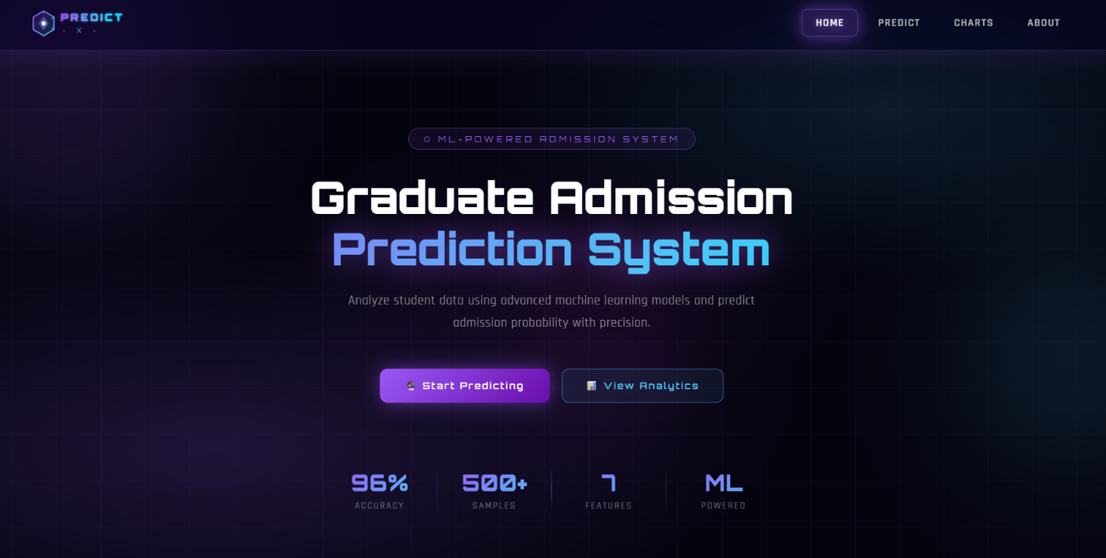

Code:

<!DOCTYPE html>
<html lang="en">
<head>
<meta charset="UTF-8" />
<meta name="viewport" content="width=device-width, initial-scale=1.0"/>
<title>Admission Prediction Dashboard</title>
<link href="https://fonts.googleapis.com/css2?family=Orbitron:wght@400;600;900&family=Rajdhani:wght@300;400;600&display=swap" rel="stylesheet"/>
<style>
:root {
--neon-purple: #9b59f5;
--neon-blue: #4fc3f7;
--neon-cyan: #00e5ff;
--neon-pink: #e040fb;
--bg-dark: #04040f;
--glass-bg: rgba(255,255,255,0.04);
--glass-border: rgba(155,89,245,0.25);
--glow-purple: 0 0 20px rgba(155,89,245,0.5), 0 0 60px rgba(155,89,245,0.2);
--glow-blue: 0 0 20px rgba(79,195,247,0.5), 0 0 60px rgba(79,195,247,0.2);
}

* { margin: 0; padding: 0; box-sizing: border-box; }

body {
font-family: 'Rajdhani', sans-serif;
background: var(--bg-dark);
color: white;
min-height: 100vh;
overflow-x: hidden;
}

/* ── ANIMATED BACKGROUND ── */
.bg-canvas {
position: fixed; inset: 0; z-index: 0;
background:
radial-gradient(ellipse 80% 60% at 20% 80%, rgba(155,89,245,0.18) 0%, transparent 60%),
radial-gradient(ellipse 60% 50% at 80% 20%, rgba(79,195,247,0.12) 0%, transparent 60%),
radial-gradient(ellipse 40% 40% at 50% 50%, rgba(224,64,251,0.06) 0%, transparent 70%),
#04040f;
}

/* Grid lines */
.bg-grid {
position: fixed; inset: 0; z-index: 0;
background-image:
linear-gradient(rgba(155,89,245,0.07) 1px, transparent 1px),
linear-gradient(90deg, rgba(155,89,245,0.07) 1px, transparent 1px);
background-size: 60px 60px;
animation: gridMove 20s linear infinite;
}
@keyframes gridMove {
0% { background-position: 0 0; }
100% { background-position: 60px 60px; }
}

/* Floating orbs */
.orb {
position: fixed; border-radius: 50%;
filter: blur(80px); z-index: 0; pointer-events: none;
animation: orbFloat 8s ease-in-out infinite;
}
.orb-1 {
width: 400px; height: 400px;
background: rgba(155,89,245,0.15);
top: -100px; left: -100px;
animation-delay: 0s;
}
.orb-2 {
width: 300px; height: 300px;
background: rgba(79,195,247,0.12);
bottom: 100px; right: -80px;
animation-delay: -3s;
}
.orb-3 {
width: 200px; height: 200px;
background: rgba(224,64,251,0.1);
top: 50%; left: 50%;
animation-delay: -6s;
}
@keyframes orbFloat {
0%, 100% { transform: translate(0,0) scale(1); }
33% { transform: translate(30px,-40px) scale(1.05); }
66% { transform: translate(-20px,20px) scale(0.95); }
}

/* ── NAVBAR (GLASSMORPHISM) ── */
.navbar {
position: fixed; top: 0; left: 0; right: 0; z-index: 100;
display: flex; align-items: center; justify-content: space-between;
padding: 0 50px;
height: 70px;
background: rgba(10, 5, 30, 0.55);
backdrop-filter: blur(20px) saturate(180%);
-webkit-backdrop-filter: blur(20px) saturate(180%);
border-bottom: 1px solid rgba(155,89,245,0.3);
box-shadow: 0 4px 30px rgba(155,89,245,0.15), inset 0 1px 0 rgba(255,255,255,0.06);
}

.nav-logo {
font-family: 'Orbitron', monospace;
font-weight: 900;
font-size: 18px;
letter-spacing: 3px;
background: linear-gradient(135deg, var(--neon-purple), var(--neon-blue));
-webkit-background-clip: text;
-webkit-text-fill-color: transparent;
background-clip: text;
filter: drop-shadow(0 0 8px rgba(155,89,245,0.8));
}

.nav-links {
display: flex; gap: 8px; align-items: center;
}
.nav-links a {
color: rgba(255,255,255,0.7);
text-decoration: none;
font-size: 14px;
font-weight: 600;
letter-spacing: 1.5px;
text-transform: uppercase;
padding: 8px 18px;
border-radius: 8px;
position: relative;
transition: all 0.3s ease;
border: 1px solid transparent;
}
.nav-links a:hover {
color: white;
background: rgba(155,89,245,0.15);
border-color: rgba(155,89,245,0.4);
box-shadow: 0 0 15px rgba(155,89,245,0.3);
text-shadow: 0 0 8px rgba(155,89,245,0.8);
}
.nav-links a.active {
color: white;
background: rgba(155,89,245,0.2);
border-color: rgba(155,89,245,0.5);
box-shadow: var(--glow-purple);
text-shadow: 0 0 10px var(--neon-purple);
}

.nav-btn {
padding: 9px 22px;
border-radius: 8px;
border: 1px solid var(--neon-purple);
background: rgba(155,89,245,0.2);
color: white;
font-family: 'Orbitron', monospace;
font-size: 11px;
font-weight: 600;
letter-spacing: 2px;
cursor: pointer;
transition: all 0.3s;
text-decoration: none;
box-shadow: 0 0 15px rgba(155,89,245,0.3);
}
.nav-btn:hover {
background: rgba(155,89,245,0.4);
box-shadow: var(--glow-purple);
transform: translateY(-1px);
}

/* ── MAIN CONTENT ── */
.main {
position: relative; z-index: 10;
padding-top: 70px;
min-height: 100vh;
}

/* ── HERO ── */
.hero {
text-align: center;
padding: 100px 40px 60px;
position: relative;
}

.hero-tag {
display: inline-block;
font-family: 'Orbitron', monospace;
font-size: 11px;
letter-spacing: 4px;
color: var(--neon-purple);
border: 1px solid rgba(155,89,245,0.4);
padding: 6px 20px;
border-radius: 20px;
background: rgba(155,89,245,0.08);
margin-bottom: 28px;
animation: fadeSlideDown 0.8s ease both;
}

.hero h1 {
font-family: 'Orbitron', monospace;
font-size: clamp(32px, 5vw, 58px);
font-weight: 900;
line-height: 1.15;
margin-bottom: 20px;
animation: fadeSlideDown 0.8s 0.1s ease both;
}
.hero h1 .line1 { display: block; color: white; }
.hero h1 .line2 {
display: block;
background: linear-gradient(135deg, var(--neon-purple) 0%, var(--neon-blue) 60%, var(--neon-cyan) 100%);
-webkit-background-clip: text;
-webkit-text-fill-color: transparent;
background-clip: text;
filter: drop-shadow(0 0 20px rgba(155,89,245,0.6));
}

.hero p {
font-size: 17px;
color: rgba(255,255,255,0.5);
max-width: 560px;
margin: 0 auto 44px;
line-height: 1.7;
letter-spacing: 0.5px;
animation: fadeSlideDown 0.8s 0.2s ease both;
}

.hero-btns {
display: flex; gap: 16px; justify-content: center;
flex-wrap: wrap;
animation: fadeSlideDown 0.8s 0.3s ease both;
}
.btn-primary {
padding: 14px 34px;
border: none;
border-radius: 10px;
background: linear-gradient(135deg, var(--neon-purple), #6a0dad);
color: white;
font-family: 'Orbitron', monospace;
font-size: 12px;
font-weight: 600;
letter-spacing: 2px;
cursor: pointer;
transition: all 0.3s;
box-shadow: 0 0 25px rgba(155,89,245,0.5);
text-decoration: none;
display: inline-flex; align-items: center; gap: 8px;
}
.btn-primary:hover {
transform: translateY(-3px);
box-shadow: 0 0 40px rgba(155,89,245,0.7), 0 10px 30px rgba(155,89,245,0.3);
}
.btn-secondary {
padding: 13px 32px;
border: 1px solid rgba(79,195,247,0.5);
border-radius: 10px;
background: rgba(79,195,247,0.08);
color: var(--neon-blue);
font-family: 'Orbitron', monospace;
font-size: 12px;
font-weight: 600;
letter-spacing: 2px;
cursor: pointer;
transition: all 0.3s;
text-decoration: none;
display: inline-flex; align-items: center; gap: 8px;
}
.btn-secondary:hover {
background: rgba(79,195,247,0.15);
box-shadow: var(--glow-blue);
transform: translateY(-3px);
}

/* ── STATS BAR ── */
.stats-bar {
display: flex; justify-content: center; gap: 0;
margin: 0 auto 80px;
max-width: 700px;
padding: 0 40px;
animation: fadeSlideDown 0.8s 0.4s ease both;
}
.stat-item {
flex: 1;
text-align: center;
padding: 24px 20px;
position: relative;
}
.stat-item:not(:last-child)::after {
content: '';
position: absolute; right: 0; top: 20%; bottom: 20%;
width: 1px;
background: linear-gradient(to bottom, transparent, rgba(155,89,245,0.4), transparent);
}
.stat-num {
font-family: 'Orbitron', monospace;
font-size: 30px;
font-weight: 900;
background: linear-gradient(135deg, var(--neon-purple), var(--neon-blue));
-webkit-background-clip: text;
-webkit-text-fill-color: transparent;
background-clip: text;
}
.stat-label {
font-size: 12px;
color: rgba(255,255,255,0.4);
letter-spacing: 2px;
text-transform: uppercase;
margin-top: 4px;
}

/* ── CARDS SECTION ── */
.section-label {
text-align: center;
font-family: 'Orbitron', monospace;
font-size: 11px;
letter-spacing: 5px;
color: rgba(155,89,245,0.7);
text-transform: uppercase;
margin-bottom: 12px;
}
.section-title {
text-align: center;
font-family: 'Orbitron', monospace;
font-size: clamp(22px, 3vw, 34px);
font-weight: 700;
margin-bottom: 50px;
color: white;
}
.section-title span {
background: linear-gradient(135deg, var(--neon-purple), var(--neon-cyan));
-webkit-background-clip: text;
-webkit-text-fill-color: transparent;
background-clip: text;
}

.cards-grid {
display: grid;
grid-template-columns: repeat(auto-fit, minmax(300px, 1fr));
gap: 24px;
max-width: 1100px;
margin: 0 auto;
padding: 0 40px 80px;
}

/* GLASS CARD */
.card {
background: rgba(255,255,255,0.03);
backdrop-filter: blur(20px);
-webkit-backdrop-filter: blur(20px);
border: 1px solid rgba(155,89,245,0.2);
border-radius: 20px;
padding: 34px 30px;
position: relative;
overflow: hidden;
transition: all 0.4s ease;
cursor: pointer;
text-decoration: none;
display: block;
color: white;
animation: cardFadeIn 0.8s ease both;
}
.card:nth-child(1) { animation-delay: 0.1s; }
.card:nth-child(2) { animation-delay: 0.2s; }
.card:nth-child(3) { animation-delay: 0.3s; }
.card:nth-child(4) { animation-delay: 0.4s; }

@keyframes cardFadeIn {
from { opacity: 0; transform: translateY(30px); }
to { opacity: 1; transform: translateY(0); }
}

/* Top glow line */
.card::before {
content: '';
position: absolute; top: 0; left: 20%; right: 20%; height: 1px;
background: linear-gradient(90deg, transparent, rgba(155,89,245,0.6), transparent);
transition: all 0.4s;
}
.card:hover::before {
left: 0; right: 0;
background: linear-gradient(90deg, transparent, var(--neon-purple), transparent);
box-shadow: 0 0 10px var(--neon-purple);
}

/* Hover glow */
.card::after {
content: '';
position: absolute; inset: 0;
border-radius: 20px;
opacity: 0;
transition: opacity 0.4s;
background: radial-gradient(ellipse at 50% 0%, rgba(155,89,245,0.12), transparent 70%);
}
.card:hover::after { opacity: 1; }

.card:hover {
border-color: rgba(155,89,245,0.5);
transform: translateY(-8px);
box-shadow: 0 20px 60px rgba(155,89,245,0.2), 0 0 0 1px rgba(155,89,245,0.1);
}

/* Blue variant */
.card.blue::before {
background: linear-gradient(90deg, transparent, rgba(79,195,247,0.6), transparent);
}
.card.blue:hover::before {
background: linear-gradient(90deg, transparent, var(--neon-blue), transparent);
box-shadow: 0 0 10px var(--neon-blue);
}
.card.blue::after {
background: radial-gradient(ellipse at 50% 0%, rgba(79,195,247,0.12), transparent 70%);
}
.card.blue:hover {
border-color: rgba(79,195,247,0.5);
box-shadow: 0 20px 60px rgba(79,195,247,0.15), 0 0 0 1px rgba(79,195,247,0.1);
}

/* Pink variant */
.card.pink::before {
background: linear-gradient(90deg, transparent, rgba(224,64,251,0.6), transparent);
}
.card.pink:hover::before {
background: linear-gradient(90deg, transparent, var(--neon-pink), transparent);
box-shadow: 0 0 10px var(--neon-pink);
}
.card.pink::after {
background: radial-gradient(ellipse at 50% 0%, rgba(224,64,251,0.1), transparent 70%);
}
.card.pink:hover {
border-color: rgba(224,64,251,0.4);
box-shadow: 0 20px 60px rgba(224,64,251,0.15);
}

.card-icon {
width: 52px; height: 52px;
border-radius: 14px;
display: flex; align-items: center; justify-content: center;
font-size: 24px;
margin-bottom: 22px;
position: relative; z-index: 1;
}
.icon-purple {
background: rgba(155,89,245,0.15);
border: 1px solid rgba(155,89,245,0.3);
box-shadow: 0 0 20px rgba(155,89,245,0.2);
}
.icon-blue {
background: rgba(79,195,247,0.1);
border: 1px solid rgba(79,195,247,0.3);
box-shadow: 0 0 20px rgba(79,195,247,0.2);
}
.icon-pink {
background: rgba(224,64,251,0.1);
border: 1px solid rgba(224,64,251,0.25);
box-shadow: 0 0 20px rgba(224,64,251,0.15);
}
.icon-cyan {
background: rgba(0,229,255,0.08);
border: 1px solid rgba(0,229,255,0.25);
box-shadow: 0 0 20px rgba(0,229,255,0.15);
}

.card-tag {
display: inline-block;
font-family: 'Orbitron', monospace;
font-size: 9px;
letter-spacing: 2px;
padding: 3px 10px;
border-radius: 4px;
margin-bottom: 12px;
text-transform: uppercase;
position: relative; z-index: 1;
}
.tag-purple { background: rgba(155,89,245,0.15); color: var(--neon-purple); border: 1px solid rgba(155,89,245,0.3); }
.tag-blue { background: rgba(79,195,247,0.1); color: var(--neon-blue); border: 1px solid rgba(79,195,247,0.3); }
.tag-pink { background: rgba(224,64,251,0.1); color: var(--neon-pink); border: 1px solid rgba(224,64,251,0.25); }
.tag-cyan { background: rgba(0,229,255,0.08); color: var(--neon-cyan); border: 1px solid rgba(0,229,255,0.25); }

.card h3 {
font-family: 'Orbitron', monospace;
font-size: 18px;
font-weight: 700;
margin-bottom: 10px;
position: relative; z-index: 1;
letter-spacing: 1px;
}
.card p {
font-size: 14px;
color: rgba(255,255,255,0.45);
line-height: 1.7;
position: relative; z-index: 1;
margin-bottom: 24px;
}

.card-footer {
display: flex; align-items: center; justify-content: space-between;
position: relative; z-index: 1;
border-top: 1px solid rgba(255,255,255,0.06);
padding-top: 18px;
}
.card-cta {
font-family: 'Orbitron', monospace;
font-size: 10px;
letter-spacing: 2px;
text-transform: uppercase;
color: rgba(255,255,255,0.5);
transition: color 0.3s;
}
.card:hover .card-cta { color: white; }
.card-arrow {
width: 32px; height: 32px;
border-radius: 8px;
border: 1px solid rgba(155,89,245,0.3);
background: rgba(155,89,245,0.1);
display: flex; align-items: center; justify-content: center;
font-size: 14px;
transition: all 0.3s;
}
.card:hover .card-arrow {
background: rgba(155,89,245,0.3);
border-color: var(--neon-purple);
transform: translate(2px, -2px);
box-shadow: 0 0 10px rgba(155,89,245,0.4);
}
.card.blue .card-arrow {
border-color: rgba(79,195,247,0.3);
background: rgba(79,195,247,0.08);
}
.card.blue:hover .card-arrow {
background: rgba(79,195,247,0.2);
border-color: var(--neon-blue);
box-shadow: 0 0 10px rgba(79,195,247,0.4);
}

/* ── BOTTOM BANNER ── */
.banner {
max-width: 1100px;
margin: 0 auto 80px;
padding: 0 40px;
}
.banner-inner {
background: rgba(255,255,255,0.02);
border: 1px solid rgba(155,89,245,0.2);
border-radius: 20px;
padding: 40px 50px;
display: flex;
align-items: center;
justify-content: space-between;
gap: 30px;
flex-wrap: wrap;
position: relative;
overflow: hidden;
backdrop-filter: blur(10px);
}
.banner-inner::before {
content: '';
position: absolute; top: 0; left: 0; right: 0; height: 1px;
background: linear-gradient(90deg, transparent, rgba(155,89,245,0.5), rgba(79,195,247,0.5), transparent);
}
.banner-text h3 {
font-family: 'Orbitron', monospace;
font-size: 20px;
margin-bottom: 8px;
}
.banner-text p {
color: rgba(255,255,255,0.4);
font-size: 14px;
}

/* ── FOOTER ── */
footer {
text-align: center;
padding: 30px;
border-top: 1px solid rgba(155,89,245,0.1);
color: rgba(255,255,255,0.2);
font-size: 13px;
letter-spacing: 2px;
font-family: 'Orbitron', monospace;
position: relative; z-index: 10;
}

/* ── ANIMATIONS ── */
@keyframes fadeSlideDown {
from { opacity: 0; transform: translateY(-20px); }
to { opacity: 1; transform: translateY(0); }
}

/* ── RESPONSIVE ── */
@media (max-width: 768px) {
.navbar { padding: 0 20px; }
.nav-links { display: none; }
.hero { padding: 80px 20px 40px; }
.cards-grid { padding: 0 20px 60px; }
.banner { padding: 0 20px; }
.banner-inner { padding: 30px 25px; flex-direction: column; }
.stats-bar { padding: 0 20px; }
.stat-num { font-size: 22px; }
}
</style>
</head>
<body>

<!-- Background layers -->
<div class="bg-canvas"></div>
<div class="bg-grid"></div>
<div class="orb orb-1"></div>
<div class="orb orb-2"></div>
<div class="orb orb-3"></div>

<!-- NAVBAR -->
<nav class="navbar">
<!-- SVG LOGO -->
<a href="/" style="text-decoration:none;display:flex;align-items:center;">
<svg width="160" height="38" viewBox="0 0 160 38" fill="none" xmlns="http://www.w3.org/2000/svg">
<defs>
<linearGradient id="hexGrad" x1="0" y1="0" x2="1" y2="1">
<stop offset="0%" stop-color="#9b59f5"/>
<stop offset="100%" stop-color="#4fc3f7"/>
</linearGradient>
<linearGradient id="textGrad" x1="0" y1="0" x2="1" y2="0">
<stop offset="0%" stop-color="#9b59f5"/>
<stop offset="60%" stop-color="#4fc3f7"/>
<stop offset="100%" stop-color="#00e5ff"/>
</linearGradient>
<filter id="glow">
<feGaussianBlur stdDeviation="1.5" result="blur"/>
<feMerge><feMergeNode in="blur"/><feMergeNode in="SourceGraphic"/></feMerge>
</filter>
</defs>
<!-- Hexagon icon -->
<polygon points="19,3 33,11 33,27 19,35 5,27 5,11" fill="url(#hexGrad)" opacity="0.15" filter="url(#glow)"/>
<polygon points="19,3 33,11 33,27 19,35 5,27 5,11" fill="none" stroke="url(#hexGrad)" stroke-width="1.5"/>
<!-- Inner diamond -->
<polygon points="19,10 26,19 19,28 12,19" fill="url(#hexGrad)" opacity="0.5"/>
<!-- Center dot -->
<circle cx="19" cy="19" r="3" fill="white" opacity="0.9"/>
<!-- Tick marks on hex -->
<line x1="19" y1="3" x2="19" y2="7" stroke="#9b59f5" stroke-width="1.2" opacity="0.8"/>
<line x1="33" y1="11" x2="29.5" y2="13" stroke="#4fc3f7" stroke-width="1.2" opacity="0.8"/>
<line x1="33" y1="27" x2="29.5" y2="25" stroke="#4fc3f7" stroke-width="1.2" opacity="0.8"/>
<!-- "ADMIT" text -->
<text x="42" y="16" font-family="'Orbitron', monospace" font-size="13" font-weight="900" fill="url(#textGrad)" letter-spacing="3" filter="url(#glow)">PREDICT</text>
<!-- "AI" accent text -->
<text x="44" y="31" font-family="'Orbitron', monospace" font-size="9" font-weight="400" fill="#4fc3f7" letter-spacing="6" opacity="0.8">· X ·</text>
<!-- Decorative line under PREDICT -->
<line x1="42" y1="19" x2="138" y2="19" stroke="url(#textGrad)" stroke-width="0.5" opacity="0.4"/>
</svg>
</a>

<div class="nav-links">
<a href="/" class="active">Home</a>
<a href="/predict_page">Predict</a>
<a href="/charts">Charts</a>
<a href="/about">About</a>
</div>
</nav>

<!-- MAIN -->
<div class="main">

<!-- HERO -->
<section class="hero">
<div class="hero-tag">⬡ ML-POWERED ADMISSION SYSTEM</div>
<h1>
<span class="line1">Graduate Admission</span>
<span class="line2">Prediction System</span>
</h1>
<p>Analyze student data using advanced machine learning models and predict admission probability with precision.</p>
<div class="hero-btns">
<a href="/predict_page" class="btn-primary">🔮 Start Predicting</a>
<a href="/charts" class="btn-secondary">📊 View Analytics</a>
</div>
</section>

<!-- STATS -->
<div class="stats-bar">
<div class="stat-item">
<div class="stat-num">96%</div>
<div class="stat-label">Accuracy</div>
</div>
<div class="stat-item">
<div class="stat-num">500+</div>
<div class="stat-label">Samples</div>
</div>
<div class="stat-item">
<div class="stat-num">7</div>
<div class="stat-label">Features</div>
</div>
<div class="stat-item">
<div class="stat-num">ML</div>
<div class="stat-label">Powered</div>
</div>
</div>

<!-- CARDS -->
<div style="padding: 0 40px;">
<div class="section-label">Core Features</div>
<div class="section-title">Powerful <span>Tools</span></div>
</div>

<div class="cards-grid">

<a href="/predict_page" class="card">
<div class="card-icon icon-purple">🔮</div>
<div class="card-tag tag-purple">AI Prediction</div>
<h3>Admission Predictor</h3>
<p>Enter GRE score, TOEFL, CGPA, SOP and more to instantly predict your admission probability using our trained ML model.</p>
<div class="card-footer">
<span class="card-cta">Start Now</span>
<div class="card-arrow">→</div>
</div>
</a>

<a href="/charts" class="card blue">
<div class="card-icon icon-blue">📊</div>
<div class="card-tag tag-blue">Data Viz</div>
<h3>Visual Analytics</h3>
<p>Explore rich interactive charts — scatter plots, correlation heatmaps, distribution graphs — derived from real admission data.</p>
<div class="card-footer">
<span class="card-cta">Explore Charts</span>
<div class="card-arrow">→</div>
</div>
</a>

<a href="/dataset" class="card pink">
<div class="card-icon icon-pink">🗂️</div>
<div class="card-tag tag-pink">Dataset</div>
<h3>Raw Data Explorer</h3>
<p>Browse the full admission dataset, filter by feature values, and understand the data patterns that power our predictions.</p>
<div class="card-footer">
<span class="card-cta">Browse Data</span>
<div class="card-arrow">→</div>
</div>
</a>

<a href="/model" class="card">
<div class="card-icon icon-cyan">⚙️</div>
<div class="card-tag tag-cyan">Model Info</div>
<h3>Model Insights</h3>
<p>Understand the machine learning model behind the predictions — feature importance, accuracy metrics, and training details.</p>
<div class="card-footer">
<span class="card-cta">View Model</span>
<div class="card-arrow">→</div>
</div>
</a>

</div>

<!-- BOTTOM BANNER -->
<div class="banner">
<div class="banner-inner">
<div class="banner-text">
<h3>Ready to check your chances? 🚀</h3>
<p>Use our AI-powered predictor and get instant results based on your academic profile.</p>
</div>
<a href="/predict_page" class="btn-primary">🔮 Predict Now →</a>
</div>
</div>

</div>

<!-- FOOTER -->
<footer>⬡ ADMIT·AI &nbsp;·&nbsp; ML DASHBOARD &nbsp;·&nbsp; BUILT WITH PYTHON &amp; FLASK</footer>

</body>
</html>

PREDICTION PAGE

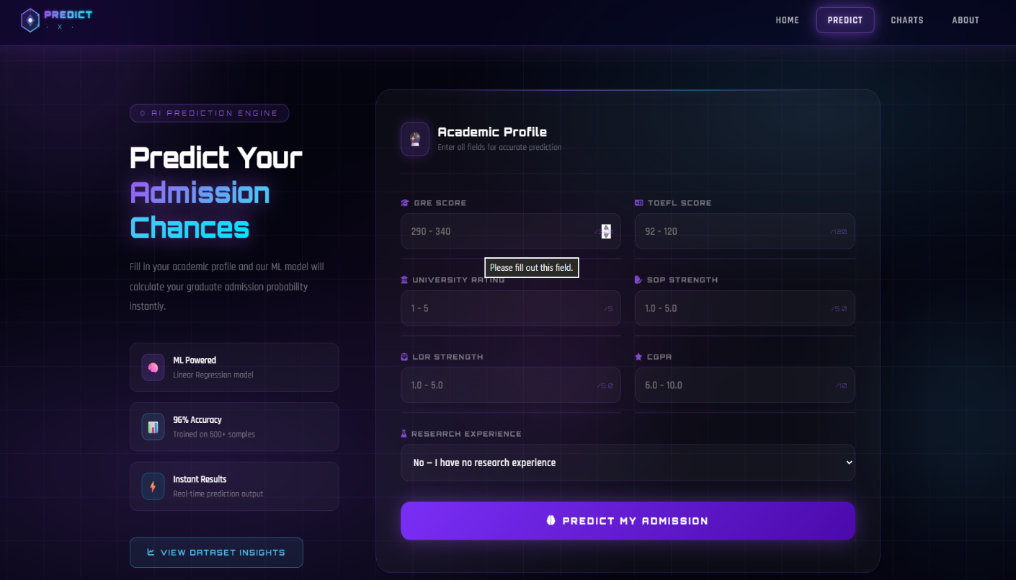

Code:

<!DOCTYPE html>
<html lang="en">
<head>
<meta charset="UTF-8"/>
<meta name="viewport" content="width=device-width, initial-scale=1.0"/>
<title>PredictX — Predict Admission</title>
<link href="https://fonts.googleapis.com/css2?family=Orbitron:wght@400;600;900&family=Rajdhani:wght@300;400;600&display=swap" rel="stylesheet"/>
<link rel="stylesheet" href="https://cdnjs.cloudflare.com/ajax/libs/font-awesome/6.4.0/css/all.min.css"/>
<style>
:root {
--neon-purple: #9b59f5;
--neon-blue: #4fc3f7;
--neon-cyan: #00e5ff;
--neon-pink: #e040fb;
--bg-dark: #04040f;
--glow-purple: 0 0 20px rgba(155,89,245,0.5), 0 0 60px rgba(155,89,245,0.2);
--glow-blue: 0 0 20px rgba(79,195,247,0.5), 0 0 60px rgba(79,195,247,0.2);
}
* { margin: 0; padding: 0; box-sizing: border-box; }
body { font-family: 'Rajdhani', sans-serif; background: var(--bg-dark); color: white; min-height: 100vh; overflow-x: hidden; }

.bg-canvas { position: fixed; inset: 0; z-index: 0;
background: radial-gradient(ellipse 80% 60% at 20% 80%, rgba(155,89,245,0.18) 0%, transparent 60%),
radial-gradient(ellipse 60% 50% at 80% 20%, rgba(79,195,247,0.12) 0%, transparent 60%),
radial-gradient(ellipse 40% 40% at 50% 50%, rgba(224,64,251,0.06) 0%, transparent 70%), #04040f; }
.bg-grid { position: fixed; inset: 0; z-index: 0;
background-image: linear-gradient(rgba(155,89,245,0.07) 1px, transparent 1px), linear-gradient(90deg, rgba(155,89,245,0.07) 1px, transparent 1px);
background-size: 60px 60px; animation: gridMove 20s linear infinite; }
@keyframes gridMove { 0% { background-position: 0 0; } 100% { background-position: 60px 60px; } }
.orb { position: fixed; border-radius: 50%; filter: blur(80px); z-index: 0; pointer-events: none; animation: orbFloat 8s ease-in-out infinite; }
.orb-1 { width:400px; height:400px; background:rgba(155,89,245,0.15); top:-100px; left:-100px; }
.orb-2 { width:300px; height:300px; background:rgba(79,195,247,0.12); bottom:100px; right:-80px; animation-delay:-3s; }
.orb-3 { width:200px; height:200px; background:rgba(224,64,251,0.1); top:50%; left:50%; animation-delay:-6s; }
@keyframes orbFloat { 0%,100% { transform:translate(0,0) scale(1); } 33% { transform:translate(30px,-40px) scale(1.05); } 66% { transform:translate(-20px,20px) scale(0.95); } }

/* NAVBAR */
.navbar { position: fixed; top:0; left:0; right:0; z-index:100;
display: flex; align-items:center; justify-content:space-between;
padding: 0 50px; height: 70px; background: rgba(10,5,30,0.55);
backdrop-filter: blur(20px) saturate(180%); -webkit-backdrop-filter: blur(20px) saturate(180%);
border-bottom: 1px solid rgba(155,89,245,0.3);
box-shadow: 0 4px 30px rgba(155,89,245,0.15), inset 0 1px 0 rgba(255,255,255,0.06); }
.nav-links { display:flex; gap:8px; align-items:center; }
.nav-links a { color: rgba(255,255,255,0.7); text-decoration: none; font-size:14px; font-weight:600;
letter-spacing:1.5px; text-transform:uppercase; padding: 8px 18px; border-radius:8px;
border: 1px solid transparent; transition: all 0.3s ease; }
.nav-links a:hover { color: white; background:rgba(155,89,245,0.15); border-color:rgba(155,89,245,0.4); box-shadow:0 0 15px rgba(155,89,245,0.3); text-shadow:0 0 8px rgba(155,89,245,0.8); }
.nav-links a.active { color: white; background:rgba(155,89,245,0.2); border-color:rgba(155,89,245,0.5); box-shadow: var(--glow-purple); text-shadow:0 0 10px var(--neon-purple); }

/* MAIN */
.main { position: relative; z-index:10; padding-top: 70px; min-height: 100vh; display: flex; align-items: center; justify-content: center; padding-bottom: 60px; }
.wrapper { width: 100%; max-width: 1300px; display: flex; gap: 60px; padding: 60px 40px 40px; align-items: flex-start; animation: fadeUp 0.8s ease both; }
@keyframes fadeUp { from { opacity:0; transform:translateY(30px); } to { opacity:1; transform:translateY(0); } }

/* LEFT PANEL */
.left-panel { flex: 0 0 340px; padding-top: 20px; }
.page-tag { display: inline-block; font-family: 'Orbitron', monospace; font-size: 10px; letter-spacing:4px; color: var(--neon-purple); border: 1px solid rgba(155,89,245,0.4); padding: 5px 16px; border-radius:20px; background: rgba(155,89,245,0.08); margin-bottom: 24px; }
.left-panel h1 { font-family: 'Orbitron', monospace; font-size: clamp(26px, 3vw, 40px); font-weight: 900; line-height: 1.2; margin-bottom: 18px; }
.left-panel h1 span { background: linear-gradient(135deg, var(--neon-purple), var(--neon-blue), var(--neon-cyan)); -webkit-background-clip: text; -webkit-text-fill-color: transparent; background-clip: text; filter: drop-shadow(0 0 15px rgba(155,89,245,0.6)); }
.left-panel p { font-size: 15px; color: rgba(255,255,255,0.45); line-height: 1.8; margin-bottom: 36px; letter-spacing: 0.3px; }

.info-cards { display:flex; flex-direction:column; gap:14px; margin-bottom:36px; }
.info-card { display: flex; align-items:center; gap:14px; background: rgba(255,255,255,0.03); border: 1px solid rgba(155,89,245,0.15); border-radius: 12px; padding: 14px 18px; transition: all 0.3s; }
.info-card:hover { border-color: rgba(155,89,245,0.35); background: rgba(155,89,245,0.07); }
.info-icon { width:38px; height:38px; border-radius:10px; display:flex; align-items:center; justify-content:center; font-size:16px; flex-shrink:0; }
.ic-purple { background:rgba(155,89,245,0.15); border:1px solid rgba(155,89,245,0.3); }
.ic-blue { background:rgba(79,195,247,0.1); border:1px solid rgba(79,195,247,0.3); }
.ic-cyan { background:rgba(0,229,255,0.08); border:1px solid rgba(0,229,255,0.25); }
.info-card-text strong { display:block; font-size:14px; font-weight:600; margin-bottom:2px; color:white; }
.info-card-text span { color:rgba(255,255,255,0.4); font-size:12px; letter-spacing:0.5px; }

.chart-btn { display: inline-flex; align-items:center; gap:8px; padding: 13px 28px; border-radius:10px; border: 1px solid rgba(79,195,247,0.4); background: rgba(79,195,247,0.08); color: var(--neon-blue); font-family: 'Orbitron', monospace; font-size:11px; font-weight:600; letter-spacing:2px; cursor:pointer; text-decoration:none; transition:all 0.3s; }
.chart-btn:hover { background:rgba(79,195,247,0.18); box-shadow: var(--glow-blue); transform: translateY(-2px); }

/* FORM CARD */
.form-card { flex: 1; background: rgba(255,255,255,0.03); backdrop-filter: blur(20px); -webkit-backdrop-filter: blur(20px); border: 1px solid rgba(155,89,245,0.2); border-radius: 24px; padding: 44px 40px; position: relative; overflow:hidden; }
.form-card::before { content:''; position:absolute; top:0; left:10%; right:10%; height:1px; background: linear-gradient(90deg, transparent, rgba(155,89,245,0.7), rgba(79,195,247,0.5), transparent); box-shadow: 0 0 12px rgba(155,89,245,0.4); }
.form-header { display:flex; align-items:center; gap:14px; margin-bottom: 34px; padding-bottom: 24px; border-bottom: 1px solid rgba(155,89,245,0.12); }
.form-header-icon { width:46px; height:46px; border-radius:12px; background:rgba(155,89,245,0.15); border:1px solid rgba(155,89,245,0.35); display:flex; align-items:center; justify-content:center; font-size:20px; box-shadow: 0 0 15px rgba(155,89,245,0.25); }
.form-header-text h2 { font-family:'Orbitron', monospace; font-size:17px; font-weight:700; letter-spacing:1px; margin-bottom:3px; }
.form-header-text p { font-size:12px; color:rgba(255,255,255,0.35); letter-spacing:0.5px; }

.form-grid { display: grid; grid-template-columns: 1fr 1fr; gap: 22px; }
.full { grid-column: 1 / 3; }
.field { display:flex; flex-direction:column; gap:8px; }
.field label { font-family: 'Orbitron', monospace; font-size: 10px; font-weight:600; letter-spacing: 2px; text-transform:uppercase; color: rgba(255,255,255,0.45); display:flex; align-items:center; gap:6px; }
.field label i { font-size:11px; color:var(--neon-purple); opacity:0.8; }
.input-wrap { position:relative; border-radius:12px; background:rgba(255,255,255,0.03); border:1px solid rgba(155,89,245,0.18); transition: all 0.3s; }
.input-wrap:focus-within { border-color: rgba(155,89,245,0.6); box-shadow: 0 0 0 3px rgba(155,89,245,0.1), 0 0 20px rgba(155,89,245,0.15); background: rgba(155,89,245,0.04); }
.input-wrap input, .input-wrap select { width:100%; padding:14px 16px; background:transparent; border:none; outline:none; color:white; font-family:'Rajdhani',sans-serif; font-size:15px; font-weight:600; letter-spacing:0.5px; border-radius:12px; }
.input-wrap select option { background:#0d0920; color:white; }
.hint-tag { position:absolute; right:12px; top:50%; transform:translateY(-50%); font-family:'Orbitron',monospace; font-size:9px; letter-spacing:1px; color:rgba(155,89,245,0.5); pointer-events:none; }
.range-bar { height:2px; border-radius:2px; background:rgba(155,89,245,0.12); margin-top:4px; overflow:hidden; }
.range-fill { height:100%; background:linear-gradient(90deg, var(--neon-purple), var(--neon-blue)); border-radius:2px; width:0%; transition: width 0.4s ease; }

.submit-btn { margin-top:28px; width:100%; padding: 18px; border:none; border-radius:14px; background: linear-gradient(135deg, #7b2ff7, #4b0aab); color:white; font-family:'Orbitron',monospace; font-size:13px; font-weight:700; letter-spacing:3px; cursor:pointer; transition:all 0.3s; position:relative; overflow:hidden; box-shadow: 0 0 30px rgba(155,89,245,0.4); }
.submit-btn::before { content:''; position:absolute; inset:0; background:linear-gradient(135deg, rgba(155,89,245,0.3), rgba(79,195,247,0.2)); opacity:0; transition:opacity 0.3s; }
.submit-btn:hover { transform:translateY(-3px); box-shadow:0 0 50px rgba(155,89,245,0.6), 0 12px 30px rgba(155,89,245,0.3); }
.submit-btn:hover::before { opacity:1; }
.submit-btn span { position:relative; z-index:1; display:flex; align-items:center; justify-content:center; gap:10px; }

/* ── RESULT BOX ── */
.result { margin-top:24px; padding: 28px 30px; border-radius:16px; background: rgba(255,255,255,0.03); border: 1px solid rgba(155,89,245,0.35); position:relative; overflow:hidden; animation: resultIn 0.5s ease both; }
@keyframes resultIn { from { opacity:0; transform:scale(0.96); } to { opacity:1; transform:scale(1); } }
.result::before { content:''; position:absolute; top:0; left:0; right:0; height:1px; background: linear-gradient(90deg, transparent, var(--neon-purple), var(--neon-blue), transparent); }
.result-inner { display:flex; align-items:center; gap:24px; flex-wrap:wrap; }
.result-circle { width:90px; height:90px; border-radius:50%; flex-shrink:0; border:2px solid rgba(155,89,245,0.5); background:rgba(155,89,245,0.08); display:flex; flex-direction:column; align-items:center; justify-content:center; box-shadow: 0 0 25px rgba(155,89,245,0.25); }
.result-pct { font-family:'Orbitron',monospace; font-size:22px; font-weight:900; background:linear-gradient(135deg, var(--neon-purple), var(--neon-blue)); -webkit-background-clip:text; -webkit-text-fill-color:transparent; background-clip:text; line-height:1; }
.result-pct-label { font-size:10px; color:rgba(255,255,255,0.35); letter-spacing:1px; margin-top:3px; }
.result-info { flex:1; }

/* 3 result tag styles */
.result-tag { display:inline-block; font-family:'Orbitron',monospace; font-size:9px; letter-spacing:2px; padding:4px 12px; border-radius:4px; margin-bottom:8px; text-transform:uppercase; }
.tag-admit { background:rgba(0,229,129,0.12); color:#00e581; border:1px solid rgba(0,229,129,0.3); }
.tag-moderate { background:rgba(255,180,0,0.12); color:#ffb400; border:1px solid rgba(255,180,0,0.35); }
.tag-reject { background:rgba(255,65,65,0.12); color:#ff4141; border:1px solid rgba(255,65,65,0.3); }

.result-status { font-family:'Orbitron',monospace; font-size:18px; font-weight:700; margin-bottom:4px; letter-spacing:1px; }
.result-sub { font-size:13px; color:rgba(255,255,255,0.4); }
.result-bar { margin-top:16px; height:4px; border-radius:4px; background:rgba(255,255,255,0.06); overflow:hidden; }
.result-bar-fill { height:100%; border-radius:4px; background:linear-gradient(90deg, var(--neon-purple), var(--neon-cyan)); box-shadow:0 0 8px rgba(155,89,245,0.5); transition:width 1s ease; width:0; }

@media (max-width:1000px) { .wrapper { flex-direction:column; gap:30px; padding:90px 20px 40px; } .left-panel { flex:none; width:100%; padding-top:0; } }
@media (max-width:640px) { .navbar { padding:0 20px; } .nav-links { display:none; } .form-grid { grid-template-columns:1fr; } .full { grid-column:1; } .form-card { padding:28px 20px; } }
</style>
</head>
<body>

<div class="bg-canvas"></div>
<div class="bg-grid"></div>
<div class="orb orb-1"></div>
<div class="orb orb-2"></div>
<div class="orb orb-3"></div>

<nav class="navbar">
<a href="/" style="text-decoration:none;display:flex;align-items:center;">
<svg width="160" height="38" viewBox="0 0 160 38" fill="none" xmlns="http://www.w3.org/2000/svg">
<defs>
<linearGradient id="hexGrad" x1="0" y1="0" x2="1" y2="1"><stop offset="0%" stop-color="#9b59f5"/><stop offset="100%" stop-color="#4fc3f7"/></linearGradient>
<linearGradient id="textGrad" x1="0" y1="0" x2="1" y2="0"><stop offset="0%" stop-color="#9b59f5"/><stop offset="60%" stop-color="#4fc3f7"/><stop offset="100%" stop-color="#00e5ff"/></linearGradient>
<filter id="glow"><feGaussianBlur stdDeviation="1.5" result="blur"/><feMerge><feMergeNode in="blur"/><feMergeNode in="SourceGraphic"/></feMerge></filter>
</defs>
<polygon points="19,3 33,11 33,27 19,35 5,27 5,11" fill="url(#hexGrad)" opacity="0.15" filter="url(#glow)"/>
<polygon points="19,3 33,11 33,27 19,35 5,27 5,11" fill="none" stroke="url(#hexGrad)" stroke-width="1.5"/>
<polygon points="19,10 26,19 19,28 12,19" fill="url(#hexGrad)" opacity="0.5"/>
<circle cx="19" cy="19" r="3" fill="white" opacity="0.9"/>
<line x1="19" y1="3" x2="19" y2="7" stroke="#9b59f5" stroke-width="1.2" opacity="0.8"/>
<line x1="33" y1="11" x2="29.5" y2="13" stroke="#4fc3f7" stroke-width="1.2" opacity="0.8"/>
<line x1="33" y1="27" x2="29.5" y2="25" stroke="#4fc3f7" stroke-width="1.2" opacity="0.8"/>
<text x="42" y="16" font-family="'Orbitron', monospace" font-size="13" font-weight="900" fill="url(#textGrad)" letter-spacing="2" filter="url(#glow)">PREDICT</text>
<text x="44" y="31" font-family="'Orbitron', monospace" font-size="9" font-weight="400" fill="#4fc3f7" letter-spacing="6" opacity="0.8">· X ·</text>
<line x1="42" y1="19" x2="152" y2="19" stroke="url(#textGrad)" stroke-width="0.5" opacity="0.4"/>
</svg>
</a>
<div class="nav-links">
<a href="/">Home</a>
<a href="/predict_page" class="active">Predict</a>
<a href="/charts">Charts</a>
<a href="/about">About</a>
</div>
</nav>

<div class="main">
<div class="wrapper">

<!-- LEFT PANEL -->
<div class="left-panel">
<div class="page-tag">⬡ AI PREDICTION ENGINE</div>
<h1>Predict Your<br><span>Admission Chances</span></h1>
<p>Fill in your academic profile and our ML model will calculate your graduate admission probability instantly.</p>
<div class="info-cards">
<div class="info-card">
<div class="info-icon ic-purple">🧠</div>
<div class="info-card-text"><strong>ML Powered</strong><span>Linear Regression model</span></div>
</div>
<div class="info-card">
<div class="info-icon ic-blue">📊</div>
<div class="info-card-text"><strong>96% Accuracy</strong><span>Trained on 500 samples</span></div>
</div>
<div class="info-card">
<div class="info-icon ic-cyan">⚡</div>
<div class="info-card-text"><strong>Instant Results</strong><span>Real-time prediction output</span></div>
</div>
</div>
<a href="/charts" class="chart-btn"><i class="fa-solid fa-chart-line"></i> VIEW DATASET INSIGHTS</a>
</div>

<!-- FORM CARD -->
<div class="form-card">
<div class="form-header">
<div class="form-header-icon">🔮</div>
<div class="form-header-text">
<h2>Academic Profile</h2>
<p>Enter all fields for accurate prediction</p>
</div>
</div>

<form action="/predict" method="POST">
<div class="form-grid">

<div class="field">
<label><i class="fa-solid fa-graduation-cap"></i> GRE Score</label>
<div class="input-wrap">
<input type="number" name="gre" placeholder="290 – 340" min="260" max="340" required oninput="updateBar(this,'gre-bar',260,340)"/>
<span class="hint-tag">/340</span>
</div>
<div class="range-bar"><div class="range-fill" id="gre-bar"></div></div>
</div>

<div class="field">
<label><i class="fa-solid fa-language"></i> TOEFL Score</label>
<div class="input-wrap">
<input type="number" name="toefl" placeholder="92 – 120" min="0" max="120" required oninput="updateBar(this,'toefl-bar',0,120)"/>
<span class="hint-tag">/120</span>
</div>
<div class="range-bar"><div class="range-fill" id="toefl-bar"></div></div>
</div>

<div class="field">
<label><i class="fa-solid fa-university"></i> University Rating</label>
<div class="input-wrap">
<input type="number" name="rating" placeholder="1 – 5" min="1" max="5" required oninput="updateBar(this,'rating-bar',1,5)"/>
<span class="hint-tag">/5</span>
</div>
<div class="range-bar"><div class="range-fill" id="rating-bar"></div></div>
</div>

<div class="field">
<label><i class="fa-solid fa-file-pen"></i> SOP Strength</label>
<div class="input-wrap">
<input type="number" name="sop" placeholder="1.0 – 5.0" step="0.5" min="1" max="5" required oninput="updateBar(this,'sop-bar',1,5)"/>
<span class="hint-tag">/5.0</span>
</div>
<div class="range-bar"><div class="range-fill" id="sop-bar"></div></div>
</div>

<div class="field">
<label><i class="fa-solid fa-envelope-open-text"></i> LOR Strength</label>
<div class="input-wrap">
<input type="number" name="lor" placeholder="1.0 – 5.0" step="0.5" min="1" max="5" required oninput="updateBar(this,'lor-bar',1,5)"/>
<span class="hint-tag">/5.0</span>
</div>
<div class="range-bar"><div class="range-fill" id="lor-bar"></div></div>
</div>

<div class="field">
<label><i class="fa-solid fa-star"></i> CGPA</label>
<div class="input-wrap">
<input type="number" name="cgpa" placeholder="6.0 – 10.0" step="0.01" min="0" max="10" required oninput="updateBar(this,'cgpa-bar',0,10)"/>
<span class="hint-tag">/10</span>
</div>
<div class="range-bar"><div class="range-fill" id="cgpa-bar"></div></div>
</div>

<div class="field full">
<label><i class="fa-solid fa-flask"></i> Research Experience</label>
<div class="input-wrap">
<select name="research">
<option value="0">No — I have no research experience</option>
<option value="1">Yes — I have research experience</option>
</select>
</div>
</div>

</div>

<button type="submit" class="submit-btn">
<span><i class="fa-solid fa-brain"></i> PREDICT MY ADMISSION</span>
</button>
</form>

<!-- RESULT — 3 CONDITIONS -->
{% if prediction %}
<div class="result">
<div class="result-inner">
<div class="result-circle">
<div class="result-pct">{{ prediction }}%</div>
<div class="result-pct-label">CHANCE</div>
</div>
<div class="result-info">

{% if prediction|int >= 80 %}
<div class="result-tag tag-admit">✓ HIGH CHANCE</div>
{% elif prediction|int >= 50 %}
<div class="result-tag tag-moderate">⚖ MODERATE CHANCE</div>
{% else %}
<div class="result-tag tag-reject">✗ LOW CHANCE</div>
{% endif %}

<div class="result-status">{{ status }}</div>
<div class="result-sub">Based on your academic profile analysis</div>
<div class="result-bar">
<div class="result-bar-fill" id="result-fill" data-pct="{{ prediction }}"></div>
</div>

</div>
</div>
</div>
{% endif %}

</div>
</div>
</div>

<script>
function updateBar(input, barId, min, max) {
const bar = document.getElementById(barId);
if (!bar) return;
const val = parseFloat(input.value);
if (isNaN(val)) { bar.style.width = '0%'; return; }
bar.style.width = Math.min(100, Math.max(0, ((val - min) / (max - min)) * 100)) + '%';
}

window.addEventListener('DOMContentLoaded', function() {
const fill = document.getElementById('result-fill');
if (fill) {
const pct = parseFloat(fill.getAttribute('data-pct'));
if (!isNaN(pct)) setTimeout(() => { fill.style.width = Math.min(100, Math.max(0, pct)) + '%'; }, 100);
}
});
</script>
</body>
</html>

RESULT

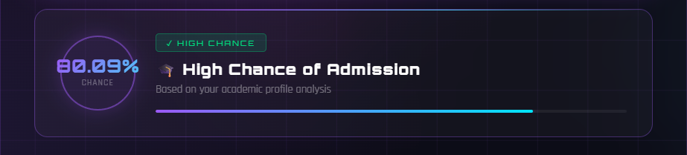

CHARTS PAGE

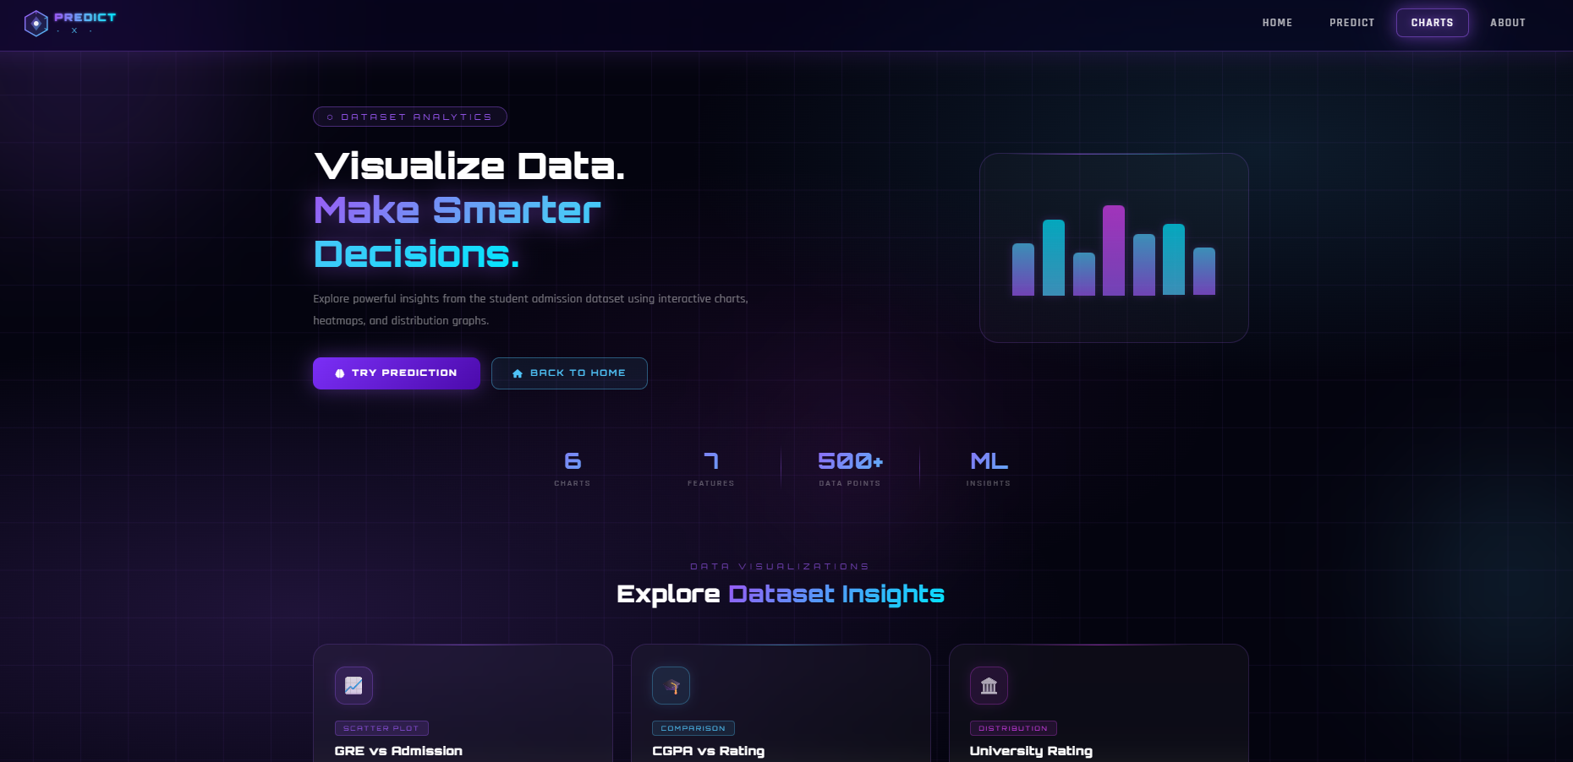

Code:

<!DOCTYPE html>
<html lang="en">
<head>
<meta charset="UTF-8"/>
<meta name="viewport" content="width=device-width, initial-scale=1.0"/>
<title>PredictX — Analytics Dashboard</title>
<link href="https://fonts.googleapis.com/css2?family=Orbitron:wght@400;600;900&family=Rajdhani:wght@300;400;600&display=swap" rel="stylesheet"/>
<link rel="stylesheet" href="https://cdnjs.cloudflare.com/ajax/libs/font-awesome/6.4.0/css/all.min.css"/>
<style>
:root {
--neon-purple: #9b59f5;
--neon-blue: #4fc3f7;
--neon-cyan: #00e5ff;
--neon-pink: #e040fb;
--bg-dark: #04040f;
--glow-purple: 0 0 20px rgba(155,89,245,0.5), 0 0 60px rgba(155,89,245,0.2);
--glow-blue: 0 0 20px rgba(79,195,247,0.5), 0 0 60px rgba(79,195,247,0.2);
}

* { margin:0; padding:0; box-sizing:border-box; }

body {
font-family: 'Rajdhani', sans-serif;
background: var(--bg-dark);
color: white;
min-height: 100vh;
overflow-x: hidden;
}

/* ── BACKGROUND ── */
.bg-canvas {
position: fixed; inset:0; z-index:0;
background:
radial-gradient(ellipse 80% 60% at 20% 80%, rgba(155,89,245,0.18) 0%, transparent 60%),
radial-gradient(ellipse 60% 50% at 80% 20%, rgba(79,195,247,0.12) 0%, transparent 60%),
radial-gradient(ellipse 40% 40% at 50% 50%, rgba(224,64,251,0.06) 0%, transparent 70%),
#04040f;
}
.bg-grid {
position: fixed; inset:0; z-index:0;
background-image:
linear-gradient(rgba(155,89,245,0.07) 1px, transparent 1px),
linear-gradient(90deg, rgba(155,89,245,0.07) 1px, transparent 1px);
background-size: 60px 60px;
animation: gridMove 20s linear infinite;
}
@keyframes gridMove {
0% { background-position:0 0; }
100% { background-position:60px 60px; }
}
.orb { position:fixed; border-radius:50%; filter:blur(80px); z-index:0; pointer-events:none; animation:orbFloat 8s ease-in-out infinite; }
.orb-1 { width:400px; height:400px; background:rgba(155,89,245,0.15); top:-100px; left:-100px; animation-delay:0s; }
.orb-2 { width:300px; height:300px; background:rgba(79,195,247,0.12); bottom:100px; right:-80px; animation-delay:-3s; }
.orb-3 { width:200px; height:200px; background:rgba(224,64,251,0.1); top:50%; left:50%; animation-delay:-6s; }
@keyframes orbFloat {
0%,100% { transform:translate(0,0) scale(1); }
33% { transform:translate(30px,-40px) scale(1.05); }
66% { transform:translate(-20px,20px) scale(0.95); }
}

/* ── NAVBAR ── */
.navbar {
position:fixed; top:0; left:0; right:0; z-index:100;
display:flex; align-items:center; justify-content:space-between;
padding:0 50px; height:70px;
background:rgba(10,5,30,0.55);
backdrop-filter:blur(20px) saturate(180%);
-webkit-backdrop-filter:blur(20px) saturate(180%);
border-bottom:1px solid rgba(155,89,245,0.3);
box-shadow:0 4px 30px rgba(155,89,245,0.15), inset 0 1px 0 rgba(255,255,255,0.06);
}
.nav-links { display:flex; gap:8px; align-items:center; }
.nav-links a {
color:rgba(255,255,255,0.7); text-decoration:none;
font-size:14px; font-weight:600; letter-spacing:1.5px; text-transform:uppercase;
padding:8px 18px; border-radius:8px; border:1px solid transparent; transition:all 0.3s ease;
}
.nav-links a:hover {
color:white; background:rgba(155,89,245,0.15);
border-color:rgba(155,89,245,0.4); box-shadow:0 0 15px rgba(155,89,245,0.3);
text-shadow:0 0 8px rgba(155,89,245,0.8);
}
.nav-links a.active {
color:white; background:rgba(155,89,245,0.2);
border-color:rgba(155,89,245,0.5); box-shadow:var(--glow-purple);
text-shadow:0 0 10px var(--neon-purple);
}

/* ── MAIN ── */
.main { position:relative; z-index:10; padding-top:70px; }

/* ── HERO ── */
.hero {
display:flex; justify-content:space-between; align-items:center;
gap:50px; padding:70px 60px 50px;
max-width:1300px; margin:0 auto;
animation:fadeUp 0.8s ease both;
}
@keyframes fadeUp {
from { opacity:0; transform:translateY(30px); }
to { opacity:1; transform:translateY(0); }
}

.hero-text { max-width:580px; }
.hero-tag {
display:inline-block; font-family:'Orbitron',monospace;
font-size:10px; letter-spacing:4px; color:var(--neon-purple);
border:1px solid rgba(155,89,245,0.4); padding:5px 16px; border-radius:20px;
background:rgba(155,89,245,0.08); margin-bottom:22px;
}
.hero-text h1 {
font-family:'Orbitron',monospace;
font-size:clamp(26px,3.5vw,46px); font-weight:900;
line-height:1.2; margin-bottom:18px;
}
.hero-text h1 span {
background:linear-gradient(135deg, var(--neon-purple), var(--neon-blue), var(--neon-cyan));
-webkit-background-clip:text; -webkit-text-fill-color:transparent; background-clip:text;
filter:drop-shadow(0 0 15px rgba(155,89,245,0.6));
}
.hero-text p {
font-size:15px; color:rgba(255,255,255,0.45);
line-height:1.8; margin-bottom:32px; letter-spacing:0.3px;
}
.hero-btns { display:flex; gap:14px; flex-wrap:wrap; }
.btn-primary {
padding:13px 28px; border:none; border-radius:10px;
background:linear-gradient(135deg, #7b2ff7, #4b0aab);
color:white; font-family:'Orbitron',monospace;
font-size:11px; font-weight:700; letter-spacing:2px;
cursor:pointer; text-decoration:none;
display:inline-flex; align-items:center; gap:8px;
box-shadow:0 0 25px rgba(155,89,245,0.4); transition:all 0.3s;
}
.btn-primary:hover { transform:translateY(-3px); box-shadow:0 0 40px rgba(155,89,245,0.6); }
.btn-secondary {
padding:12px 26px; border-radius:10px;
border:1px solid rgba(79,195,247,0.4);
background:rgba(79,195,247,0.08); color:var(--neon-blue);
font-family:'Orbitron',monospace; font-size:11px; font-weight:600; letter-spacing:2px;
cursor:pointer; text-decoration:none;
display:inline-flex; align-items:center; gap:8px; transition:all 0.3s;
}
.btn-secondary:hover { background:rgba(79,195,247,0.18); box-shadow:var(--glow-blue); transform:translateY(-3px); }

/* Hero visual box */
.hero-visual {
flex-shrink:0; width:340px; height:240px;
background:rgba(255,255,255,0.02);
border:1px solid rgba(155,89,245,0.2);
border-radius:24px; position:relative; overflow:hidden;
display:flex; align-items:center; justify-content:center;
}
.hero-visual::before {
content:''; position:absolute; top:0; left:10%; right:10%; height:1px;
background:linear-gradient(90deg, transparent, rgba(155,89,245,0.6), rgba(79,195,247,0.4), transparent);
}
/* mini bar chart inside hero visual */
.mini-chart { display:flex; align-items:flex-end; gap:10px; padding:20px; height:160px; }
.mini-bar {
width:28px; border-radius:6px 6px 0 0;
background:linear-gradient(to top, var(--neon-purple), var(--neon-blue));
opacity:0.7; animation:barGrow 1s ease both;
box-shadow:0 0 10px rgba(155,89,245,0.3);
}
@keyframes barGrow {
from { transform:scaleY(0); transform-origin:bottom; }
to { transform:scaleY(1); transform-origin:bottom; }
}
.mini-bar:nth-child(1) { height:55%; animation-delay:0.1s; }
.mini-bar:nth-child(2) { height:80%; animation-delay:0.2s; background:linear-gradient(to top, var(--neon-blue), var(--neon-cyan)); }
.mini-bar:nth-child(3) { height:45%; animation-delay:0.3s; }
.mini-bar:nth-child(4) { height:95%; animation-delay:0.4s; background:linear-gradient(to top, var(--neon-purple), var(--neon-pink)); }
.mini-bar:nth-child(5) { height:65%; animation-delay:0.5s; }
.mini-bar:nth-child(6) { height:75%; animation-delay:0.6s; background:linear-gradient(to top, var(--neon-blue), var(--neon-cyan)); }
.mini-bar:nth-child(7) { height:50%; animation-delay:0.7s; }

/* ── STATS ROW ── */
.stats-row {
display:flex; justify-content:center; gap:0;
max-width:700px; margin:0 auto 70px;
animation:fadeUp 0.8s 0.2s ease both;
}
.stat-item { flex:1; text-align:center; padding:22px 16px; position:relative; }
.stat-item:not(:last-child)::after {
content:''; position:absolute; right:0; top:20%; bottom:20%; width:1px;
background:linear-gradient(to bottom, transparent, rgba(155,89,245,0.4), transparent);
}
.stat-num {
font-family:'Orbitron',monospace; font-size:28px; font-weight:900;
background:linear-gradient(135deg, var(--neon-purple), var(--neon-blue));
-webkit-background-clip:text; -webkit-text-fill-color:transparent; background-clip:text;
}
.stat-label { font-size:11px; color:rgba(255,255,255,0.35); letter-spacing:2px; text-transform:uppercase; margin-top:4px; }

/* ── SECTION ── */
.section { padding:0 60px 80px; max-width:1300px; margin:0 auto; }
.section-label {
text-align:center; font-family:'Orbitron',monospace;
font-size:10px; letter-spacing:5px; color:rgba(155,89,245,0.7);
text-transform:uppercase; margin-bottom:10px;
}
.section-title {
text-align:center; font-family:'Orbitron',monospace;
font-size:clamp(20px,2.5vw,30px); font-weight:700; margin-bottom:44px;
}
.section-title span {
background:linear-gradient(135deg, var(--neon-purple), var(--neon-cyan));
-webkit-background-clip:text; -webkit-text-fill-color:transparent; background-clip:text;
}

/* ── CHART CARDS GRID ── */
.charts-grid {
display:grid;
grid-template-columns:repeat(auto-fit, minmax(290px,1fr));
gap:22px;
}

/* CHART CARD */
.chart-card {
background:rgba(255,255,255,0.03);
backdrop-filter:blur(20px);
-webkit-backdrop-filter:blur(20px);
border:1px solid rgba(155,89,245,0.18);
border-radius:20px; padding:28px 26px;
position:relative; overflow:hidden;
transition:all 0.4s ease;
text-decoration:none; color:white; display:block;
animation:cardIn 0.7s ease both;
}
.chart-card:nth-child(1) { animation-delay:0.05s; }
.chart-card:nth-child(2) { animation-delay:0.10s; }
.chart-card:nth-child(3) { animation-delay:0.15s; }
.chart-card:nth-child(4) { animation-delay:0.20s; }
.chart-card:nth-child(5) { animation-delay:0.25s; }
.chart-card:nth-child(6) { animation-delay:0.30s; }
@keyframes cardIn {
from { opacity:0; transform:translateY(28px); }
to { opacity:1; transform:translateY(0); }
}

/* top glow line */
.chart-card::before {
content:''; position:absolute; top:0; left:20%; right:20%; height:1px;
background:linear-gradient(90deg, transparent, rgba(155,89,245,0.5), transparent);
transition:all 0.4s;
}
.chart-card:hover::before {
left:0; right:0;
background:linear-gradient(90deg, transparent, var(--neon-purple), var(--neon-blue), transparent);
box-shadow:0 0 10px rgba(155,89,245,0.4);
}
/* hover glow overlay */
.chart-card::after {
content:''; position:absolute; inset:0; border-radius:20px; opacity:0;
background:radial-gradient(ellipse at 50% 0%, rgba(155,89,245,0.1), transparent 70%);
transition:opacity 0.4s;
}
.chart-card:hover::after { opacity:1; }
.chart-card:hover {
border-color:rgba(155,89,245,0.45);
transform:translateY(-8px);
box-shadow:0 20px 50px rgba(155,89,245,0.18), 0 0 0 1px rgba(155,89,245,0.08);
}

/* blue variant */
.chart-card.blue::before { background:linear-gradient(90deg, transparent, rgba(79,195,247,0.5), transparent); }
.chart-card.blue:hover::before { background:linear-gradient(90deg, transparent, var(--neon-blue), transparent); box-shadow:0 0 10px rgba(79,195,247,0.4); }
.chart-card.blue::after { background:radial-gradient(ellipse at 50% 0%, rgba(79,195,247,0.1), transparent 70%); }
.chart-card.blue:hover { border-color:rgba(79,195,247,0.45); box-shadow:0 20px 50px rgba(79,195,247,0.15); }

/* pink variant */
.chart-card.pink::before { background:linear-gradient(90deg, transparent, rgba(224,64,251,0.5), transparent); }
.chart-card.pink:hover::before { background:linear-gradient(90deg, transparent, var(--neon-pink), transparent); box-shadow:0 0 10px rgba(224,64,251,0.4); }
.chart-card.pink::after { background:radial-gradient(ellipse at 50% 0%, rgba(224,64,251,0.08), transparent 70%); }
.chart-card.pink:hover { border-color:rgba(224,64,251,0.4); box-shadow:0 20px 50px rgba(224,64,251,0.12); }

/* cyan variant */
.chart-card.cyan::before { background:linear-gradient(90deg, transparent, rgba(0,229,255,0.4), transparent); }
.chart-card.cyan:hover::before { background:linear-gradient(90deg, transparent, var(--neon-cyan), transparent); box-shadow:0 0 10px rgba(0,229,255,0.4); }
.chart-card.cyan:hover { border-color:rgba(0,229,255,0.4); box-shadow:0 20px 50px rgba(0,229,255,0.12); }

/* card icon */
.card-icon {
width:48px; height:48px; border-radius:13px;
display:flex; align-items:center; justify-content:center;
font-size:22px; margin-bottom:18px; position:relative; z-index:1;
}
.ic-purple { background:rgba(155,89,245,0.15); border:1px solid rgba(155,89,245,0.3); box-shadow:0 0 15px rgba(155,89,245,0.15); }
.ic-blue { background:rgba(79,195,247,0.1); border:1px solid rgba(79,195,247,0.3); box-shadow:0 0 15px rgba(79,195,247,0.15); }
.ic-pink { background:rgba(224,64,251,0.1); border:1px solid rgba(224,64,251,0.25); box-shadow:0 0 15px rgba(224,64,251,0.12); }
.ic-cyan { background:rgba(0,229,255,0.08); border:1px solid rgba(0,229,255,0.25); box-shadow:0 0 15px rgba(0,229,255,0.12); }
.ic-green { background:rgba(0,229,129,0.08); border:1px solid rgba(0,229,129,0.25); box-shadow:0 0 15px rgba(0,229,129,0.12); }
.ic-amber { background:rgba(255,180,0,0.08); border:1px solid rgba(255,180,0,0.25); box-shadow:0 0 15px rgba(255,180,0,0.12); }

/* card tag */
.card-tag {
display:inline-block; font-family:'Orbitron',monospace;
font-size:8px; letter-spacing:2px; padding:3px 10px;
border-radius:4px; margin-bottom:10px; text-transform:uppercase;
position:relative; z-index:1;
}
.tag-purple { background:rgba(155,89,245,0.15); color:var(--neon-purple); border:1px solid rgba(155,89,245,0.3); }
.tag-blue { background:rgba(79,195,247,0.1); color:var(--neon-blue); border:1px solid rgba(79,195,247,0.3); }
.tag-pink { background:rgba(224,64,251,0.1); color:var(--neon-pink); border:1px solid rgba(224,64,251,0.25); }
.tag-cyan { background:rgba(0,229,255,0.08); color:var(--neon-cyan); border:1px solid rgba(0,229,255,0.25); }
.tag-green { background:rgba(0,229,129,0.08); color:#00e581; border:1px solid rgba(0,229,129,0.25); }
.tag-amber { background:rgba(255,180,0,0.08); color:#ffb400; border:1px solid rgba(255,180,0,0.25); }

.chart-card h3 {
font-family:'Orbitron',monospace; font-size:15px; font-weight:700;
letter-spacing:0.5px; margin-bottom:8px; position:relative; z-index:1;
}
.chart-card p {
font-size:13px; color:rgba(255,255,255,0.4);
line-height:1.7; margin-bottom:22px; position:relative; z-index:1;
}

/* mini sparkline preview inside card */
.card-preview {
height:48px; margin-bottom:20px;
display:flex; align-items:flex-end; gap:4px;
position:relative; z-index:1; opacity:0.6;
}
.spark-bar {
flex:1; border-radius:3px 3px 0 0;
background:linear-gradient(to top, var(--neon-purple), var(--neon-blue));
transition:opacity 0.3s;
}
.chart-card:hover .card-preview { opacity:1; }
.spark-line {
position:absolute; inset:0;
background: none;
}

/* card footer */
.card-footer {
display:flex; align-items:center; justify-content:space-between;
border-top:1px solid rgba(255,255,255,0.05); padding-top:16px;
position:relative; z-index:1;
}
.card-cta {
font-family:'Orbitron',monospace; font-size:9px;
letter-spacing:2px; text-transform:uppercase; color:rgba(255,255,255,0.4);
transition:color 0.3s;
}
.chart-card:hover .card-cta { color:white; }
.card-arrow {
width:30px; height:30px; border-radius:8px;
border:1px solid rgba(155,89,245,0.3);
background:rgba(155,89,245,0.1);
display:flex; align-items:center; justify-content:center;
font-size:13px; transition:all 0.3s;
}
.chart-card:hover .card-arrow {
background:rgba(155,89,245,0.3); border-color:var(--neon-purple);
transform:translate(2px,-2px); box-shadow:0 0 10px rgba(155,89,245,0.4);
}
.chart-card.blue .card-arrow { border-color:rgba(79,195,247,0.3); background:rgba(79,195,247,0.08); }
.chart-card.blue:hover .card-arrow { background:rgba(79,195,247,0.2); border-color:var(--neon-blue); box-shadow:0 0 10px rgba(79,195,247,0.4); }

/* ── BOTTOM BANNER ── */
.banner { max-width:1300px; margin:0 auto 80px; padding:0 60px; }
.banner-inner {
background:rgba(255,255,255,0.02); border:1px solid rgba(155,89,245,0.2);
border-radius:20px; padding:38px 48px;
display:flex; align-items:center; justify-content:space-between;
gap:30px; flex-wrap:wrap; position:relative; overflow:hidden;
backdrop-filter:blur(10px);
}
.banner-inner::before {
content:''; position:absolute; top:0; left:0; right:0; height:1px;
background:linear-gradient(90deg, transparent, rgba(155,89,245,0.5), rgba(79,195,247,0.4), transparent);
}
.banner-text h3 { font-family:'Orbitron',monospace; font-size:18px; margin-bottom:6px; }
.banner-text p { color:rgba(255,255,255,0.4); font-size:13px; }

/* ── FOOTER ── */
footer {
text-align:center; padding:28px;
border-top:1px solid rgba(155,89,245,0.1);
color:rgba(255,255,255,0.2); font-size:12px; letter-spacing:2px;
font-family:'Orbitron',monospace; position:relative; z-index:10;
}

/* ── RESPONSIVE ── */
@media (max-width:900px) {
.hero { flex-direction:column; padding:90px 20px 40px; }
.hero-visual { width:100%; }
.section { padding:0 20px 60px; }
.banner { padding:0 20px; }
.banner-inner { flex-direction:column; padding:28px 22px; }
.stats-row { padding:0 20px; }
}
@media (max-width:640px) {
.navbar { padding:0 20px; }
.nav-links { display:none; }
.charts-grid { grid-template-columns:1fr; }
}
</style>
</head>
<body>

<!-- Background -->
<div class="bg-canvas"></div>
<div class="bg-grid"></div>
<div class="orb orb-1"></div>
<div class="orb orb-2"></div>
<div class="orb orb-3"></div>

<!-- NAVBAR -->
<nav class="navbar">
<a href="/" style="text-decoration:none;display:flex;align-items:center;">
<svg width="160" height="38" viewBox="0 0 160 38" fill="none" xmlns="http://www.w3.org/2000/svg">
<defs>
<linearGradient id="hexGrad" x1="0" y1="0" x2="1" y2="1">
<stop offset="0%" stop-color="#9b59f5"/>
<stop offset="100%" stop-color="#4fc3f7"/>
</linearGradient>
<linearGradient id="textGrad" x1="0" y1="0" x2="1" y2="0">
<stop offset="0%" stop-color="#9b59f5"/>
<stop offset="60%" stop-color="#4fc3f7"/>
<stop offset="100%" stop-color="#00e5ff"/>
</linearGradient>
<filter id="glow">
<feGaussianBlur stdDeviation="1.5" result="blur"/>
<feMerge><feMergeNode in="blur"/><feMergeNode in="SourceGraphic"/></feMerge>
</filter>
</defs>
<polygon points="19,3 33,11 33,27 19,35 5,27 5,11" fill="url(#hexGrad)" opacity="0.15" filter="url(#glow)"/>
<polygon points="19,3 33,11 33,27 19,35 5,27 5,11" fill="none" stroke="url(#hexGrad)" stroke-width="1.5"/>
<polygon points="19,10 26,19 19,28 12,19" fill="url(#hexGrad)" opacity="0.5"/>
<circle cx="19" cy="19" r="3" fill="white" opacity="0.9"/>
<line x1="19" y1="3" x2="19" y2="7" stroke="#9b59f5" stroke-width="1.2" opacity="0.8"/>
<line x1="33" y1="11" x2="29.5" y2="13" stroke="#4fc3f7" stroke-width="1.2" opacity="0.8"/>
<line x1="33" y1="27" x2="29.5" y2="25" stroke="#4fc3f7" stroke-width="1.2" opacity="0.8"/>
<text x="42" y="16" font-family="'Orbitron', monospace" font-size="13" font-weight="900" fill="url(#textGrad)" letter-spacing="2" filter="url(#glow)">PREDICT</text>
<text x="44" y="31" font-family="'Orbitron', monospace" font-size="9" font-weight="400" fill="#4fc3f7" letter-spacing="6" opacity="0.8">· X ·</text>
<line x1="42" y1="19" x2="152" y2="19" stroke="url(#textGrad)" stroke-width="0.5" opacity="0.4"/>
</svg>
</a>
<div class="nav-links">
<a href="/">Home</a>
<a href="/predict_page">Predict</a>
<a href="/charts" class="active">Charts</a>
<a href="/about">About</a>
</div>
</nav>

<!-- MAIN -->
<div class="main">

<!-- HERO -->
<div class="hero">
<div class="hero-text">
<div class="hero-tag">⬡ DATASET ANALYTICS</div>
<h1>Visualize Data.<br><span>Make Smarter Decisions.</span></h1>
<p>Explore powerful insights from the student admission dataset using interactive charts, heatmaps, and distribution graphs.</p>
<div class="hero-btns">
<a href="/predict_page" class="btn-primary"><i class="fa-solid fa-brain"></i> TRY PREDICTION</a>
<a href="/" class="btn-secondary"><i class="fa-solid fa-house"></i> BACK TO HOME</a>
</div>
</div>
<div class="hero-visual">
<div class="mini-chart">
<div class="mini-bar"></div>
<div class="mini-bar"></div>
<div class="mini-bar"></div>
<div class="mini-bar"></div>
<div class="mini-bar"></div>
<div class="mini-bar"></div>
<div class="mini-bar"></div>
</div>
</div>
</div>

<!-- STATS -->
<div class="stats-row">
<div class="stat-item">
<div class="stat-num">6</div>
<div class="stat-label">Charts</div>
</div>
<div class="stat-item">
<div class="stat-num">7</div>
<div class="stat-label">Features</div>
</div>
<div class="stat-item">
<div class="stat-num">500+</div>
<div class="stat-label">Data Points</div>
</div>
<div class="stat-item">
<div class="stat-num">ML</div>
<div class="stat-label">Insights</div>
</div>
</div>

<!-- CHART SECTION -->
<div class="section">
<div class="section-label">Data Visualizations</div>
<div class="section-title">Explore <span>Dataset Insights</span></div>

<div class="charts-grid">

<!-- GRE vs Admission -->
<a href="/gre_chart" class="chart-card">
<div class="card-icon ic-purple">📈</div>
<div class="card-tag tag-purple">Scatter Plot</div>
<h3>GRE vs Admission</h3>
<p>Analyze the direct impact of GRE score on graduate admission probability across all applicants.</p>
<div class="card-preview">
<div class="spark-bar" style="height:40%"></div>
<div class="spark-bar" style="height:55%;background:linear-gradient(to top,var(--neon-blue),var(--neon-cyan))"></div>
<div class="spark-bar" style="height:70%"></div>
<div class="spark-bar" style="height:85%;background:linear-gradient(to top,var(--neon-blue),var(--neon-cyan))"></div>
<div class="spark-bar" style="height:90%"></div>
<div class="spark-bar" style="height:95%;background:linear-gradient(to top,var(--neon-blue),var(--neon-cyan))"></div>
<div class="spark-bar" style="height:100%"></div>
</div>
<div class="card-footer">
<span class="card-cta">View Chart</span>
<div class="card-arrow">→</div>
</div>
</a>

<!-- CGPA vs Rating -->
<a href="/cgpa_chart" class="chart-card blue">
<div class="card-icon ic-blue">🎓</div>
<div class="card-tag tag-blue">Comparison</div>
<h3>CGPA vs Rating</h3>
<p>Compare CGPA distributions across different university ratings to find admission patterns.</p>
<div class="card-preview">
<div class="spark-bar" style="height:60%;background:linear-gradient(to top,var(--neon-blue),var(--neon-cyan))"></div>
<div class="spark-bar" style="height:75%;background:linear-gradient(to top,var(--neon-cyan),#fff)"></div>
<div class="spark-bar" style="height:50%;background:linear-gradient(to top,var(--neon-blue),var(--neon-cyan))"></div>
<div class="spark-bar" style="height:88%;background:linear-gradient(to top,var(--neon-cyan),#fff)"></div>
<div class="spark-bar" style="height:70%;background:linear-gradient(to top,var(--neon-blue),var(--neon-cyan))"></div>
<div class="spark-bar" style="height:45%;background:linear-gradient(to top,var(--neon-cyan),#fff)"></div>
<div class="spark-bar" style="height:80%;background:linear-gradient(to top,var(--neon-blue),var(--neon-cyan))"></div>
</div>
<div class="card-footer">
<span class="card-cta">View Chart</span>
<div class="card-arrow">→</div>
</div>
</a>

<!-- University Rating -->
<a href="/rating_chart" class="chart-card pink">
<div class="card-icon ic-pink">🏛️</div>
<div class="card-tag tag-pink">Distribution</div>
<h3>University Rating</h3>
<p>Explore the distribution of university ratings and see which ratings dominate the dataset.</p>
<div class="card-preview">
<div class="spark-bar" style="height:30%;background:linear-gradient(to top,var(--neon-pink),#ff8aff)"></div>
<div class="spark-bar" style="height:65%;background:linear-gradient(to top,var(--neon-purple),var(--neon-pink))"></div>
<div class="spark-bar" style="height:100%;background:linear-gradient(to top,var(--neon-pink),#ff8aff)"></div>
<div class="spark-bar" style="height:80%;background:linear-gradient(to top,var(--neon-purple),var(--neon-pink))"></div>
<div class="spark-bar" style="height:45%;background:linear-gradient(to top,var(--neon-pink),#ff8aff)"></div>
</div>
<div class="card-footer">
<span class="card-cta">View Chart</span>
<div class="card-arrow">→</div>
</div>
</a>

<!-- Correlation Heatmap -->
<a href="/heatmap_chart" class="chart-card cyan">
<div class="card-icon ic-cyan">🔥</div>
<div class="card-tag tag-cyan">Heatmap</div>
<h3>Correlation Heatmap</h3>
<p>Discover the statistical relationships and correlations between all 7 features in the dataset.</p>
<div class="card-preview" style="display:grid;grid-template-columns:repeat(7,1fr);gap:3px;height:48px;align-items:stretch;">
<div style="background:rgba(0,229,255,0.8);border-radius:2px"></div>
<div style="background:rgba(0,229,255,0.4);border-radius:2px"></div>
<div style="background:rgba(155,89,245,0.6);border-radius:2px"></div>
<div style="background:rgba(0,229,255,0.9);border-radius:2px"></div>
<div style="background:rgba(224,64,251,0.5);border-radius:2px"></div>
<div style="background:rgba(0,229,255,0.3);border-radius:2px"></div>
<div style="background:rgba(155,89,245,0.8);border-radius:2px"></div>
</div>
<div class="card-footer">
<span class="card-cta">View Chart</span>
<div class="card-arrow">→</div>
</div>
</a>

<!-- CGPA Distribution -->
<a href="/cgpa_distribution" class="chart-card">
<div class="card-icon ic-green">📊</div>
<div class="card-tag tag-green">Histogram</div>
<h3>CGPA Distribution</h3>
<p>View the histogram of CGPA values to understand performance spread across all students.</p>
<div class="card-preview">
<div class="spark-bar" style="height:20%;background:linear-gradient(to top,#00e581,#00ffaa)"></div>
<div class="spark-bar" style="height:45%;background:linear-gradient(to top,#00e581,#00ffaa)"></div>
<div class="spark-bar" style="height:80%;background:linear-gradient(to top,#00e581,#00ffaa)"></div>
<div class="spark-bar" style="height:100%;background:linear-gradient(to top,#00e581,#00ffaa)"></div>
<div class="spark-bar" style="height:85%;background:linear-gradient(to top,#00e581,#00ffaa)"></div>
<div class="spark-bar" style="height:55%;background:linear-gradient(to top,#00e581,#00ffaa)"></div>
<div class="spark-bar" style="height:25%;background:linear-gradient(to top,#00e581,#00ffaa)"></div>
</div>
<div class="card-footer">
<span class="card-cta">View Chart</span>
<div class="card-arrow">→</div>
</div>
</a>

<!-- Research Analysis -->
<a href="/research_chart" class="chart-card blue">
<div class="card-icon ic-amber">🔬</div>
<div class="card-tag tag-amber">Analysis</div>
<h3>Research Analysis</h3>
<p>Understand how having research experience boosts admission chances compared to no experience.</p>
<div class="card-preview" style="display:flex;gap:20px;align-items:flex-end;padding:0 20px;">
<div style="flex:1;display:flex;flex-direction:column;align-items:center;gap:4px;">
<div style="width:100%;height:30px;background:rgba(255,100,100,0.4);border-radius:4px 4px 0 0;border:1px solid rgba(255,100,100,0.4)"></div>
<div style="font-size:9px;color:rgba(255,255,255,0.3);font-family:'Orbitron',monospace;letter-spacing:1px">NO</div>
</div>
<div style="flex:1;display:flex;flex-direction:column;align-items:center;gap:4px;">
<div style="width:100%;height:46px;background:rgba(0,229,255,0.3);border-radius:4px 4px 0 0;border:1px solid rgba(0,229,255,0.4)"></div>
<div style="font-size:9px;color:rgba(255,255,255,0.3);font-family:'Orbitron',monospace;letter-spacing:1px">YES</div>
</div>
</div>
<div class="card-footer">
<span class="card-cta">View Chart</span>
<div class="card-arrow">→</div>
</div>
</a>

</div>
</div>

<!-- BOTTOM BANNER -->
<div class="banner">
<div class="banner-inner">
<div class="banner-text">
<h3>Ready to predict your admission? 🚀</h3>
<p>Use insights from these charts to understand your profile, then run the ML prediction.</p>
</div>
<a href="/predict_page" class="btn-primary"><i class="fa-solid fa-brain"></i> PREDICT NOW →</a>
</div>
</div>

</div>

<!-- FOOTER -->
<footer>⬡ PREDICTX &nbsp;·&nbsp; ANALYTICS DASHBOARD &nbsp;·&nbsp; BUILT WITH FLASK 🚀</footer>

</body>
</html>

All Charts :

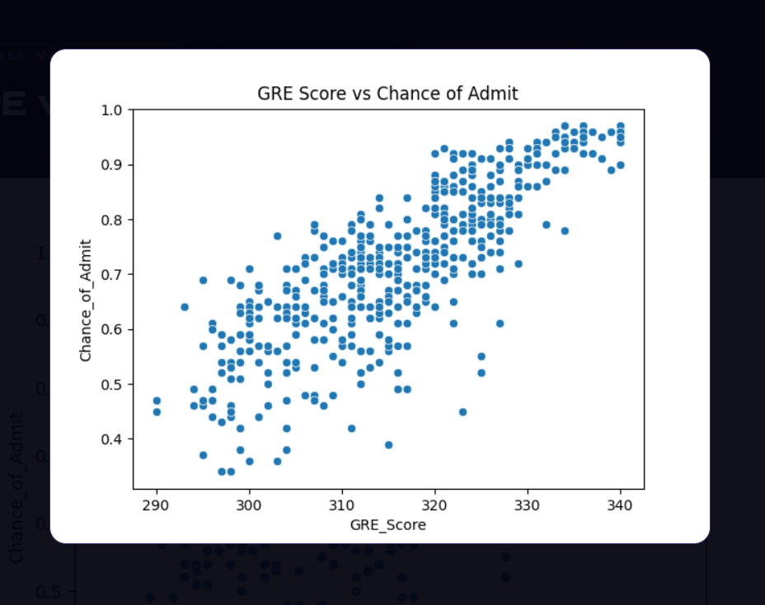

GRE Score vs Chance of Admit (Scatter Plot):

The scatter plot of GRE Score against Chance of Admission reveals a strong, clear positive linear relationship. Applicants scoring around 290 on the GRE tend to have admission chances in the range of 0.35 to 0.50, while those scoring near 340 — the maximum — see their chances rise to 0.85–0.97. The upward trend is consistent and tight across the score range, with relatively few outliers. This is fully consistent with the 0.81 correlation observed in the heatmap. It also shows that GRE score alone can be a strong signal of admission likelihood. However, there is still visible spread at each GRE score level, meaning other factors like CGPA, TOEFL, and research experience also contribute independently to the final admission probability.
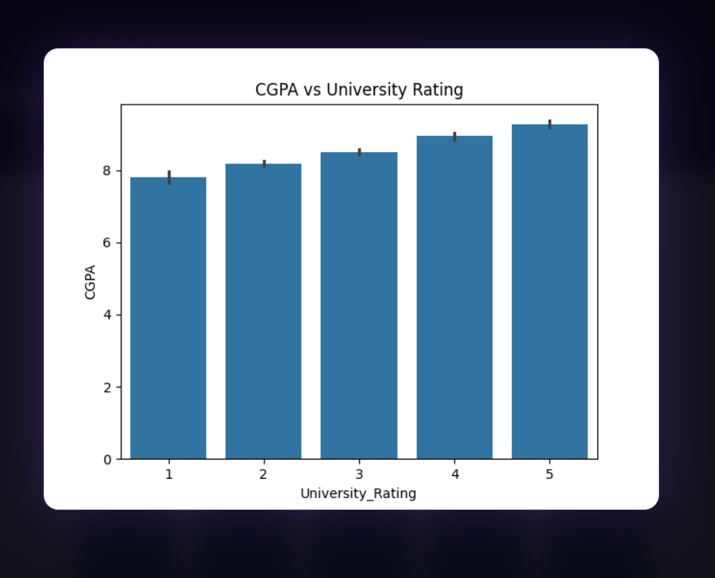

CGPA vs University Rating (Bar Chart):

This bar chart shows a steady and consistent increase in average CGPA as the university rating goes up. Applicants from Rating 1 universities average around 7.8 CGPA, while those from Rating 5 universities average approximately 9.1 CGPA. This monotonic increase confirms a strong alignment between academic performance and institutional prestige. In other words, students with higher GPAs tend to target and gain admission to better-rated universities. This also reinforces the heatmap finding that CGPA and University Rating are moderately correlated (0.71). The error bars in the chart are very small, especially at Rating 4 and 5, suggesting that the higher-rated groups are more academically homogeneous and consistently high

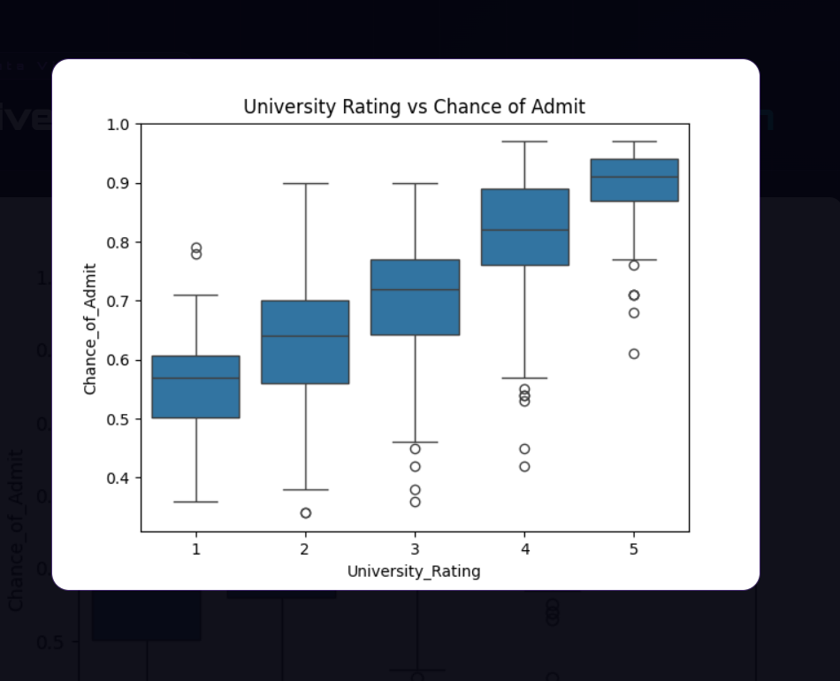

University Rating vs Chance of Admit (Box Plot):

This box plot clearly shows that as the university rating increases from 1 to 5, the median admission chance rises consistently and significantly. Rating 1 applicants have a median admission chance of roughly 0.55–0.60, with considerable spread downward to around 0.35. Rating 5 applicants cluster tightly around 0.90 to 0.93, with very little downward variation. This tells us two important things. First, students applying to higher-rated universities tend to be stronger overall candidates. Second, higher university ratings are themselves associated with better admission outcomes, possibly because students from prestigious institutions are better prepared or more competitive. The interquartile range also narrows as ratings increase, meaning top-tier applicants are more consistently strong, while lower-rated applicants show more variability in their outcomes.

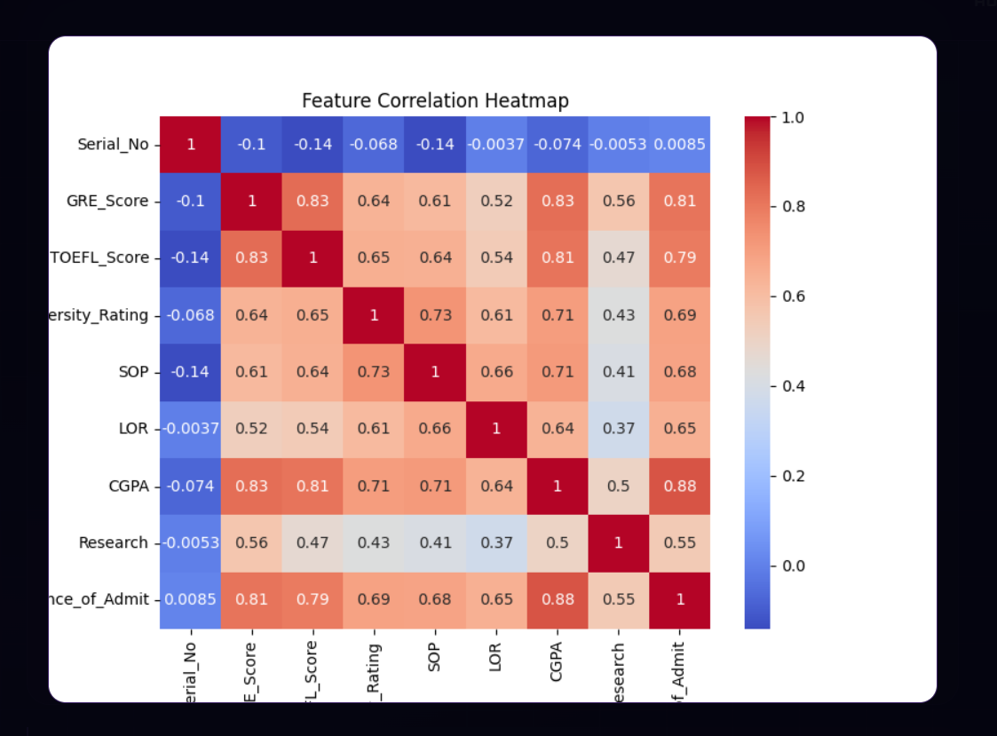

Feature Correlation (Heatmap):

The heatmap reveals how strongly each feature is related to the Chance of Admission and to each other. The key findings are as follows:
CGPA has the strongest correlation with admission at 0.88, making it the single most important predictor. GRE Score follows closely at 0.81, and TOEFL Score at 0.79, showing that standardized test performance is a major factor. University Rating (0.69) and SOP (0.68) are moderate predictors, indicating that the quality of the institution and the strength of the personal statement also play a meaningful role. LOR (0.65) has a slightly lower but still notable correlation. Research (0.55) provides a meaningful boost. Serial Number, as expected, has near-zero correlation since it is just an identifier with no predictive value.
An important additional observation is that CGPA, GRE, and TOEFL are also highly correlated with each other — for example, GRE and CGPA share a 0.83 correlation. This means that strong students tend to perform well .
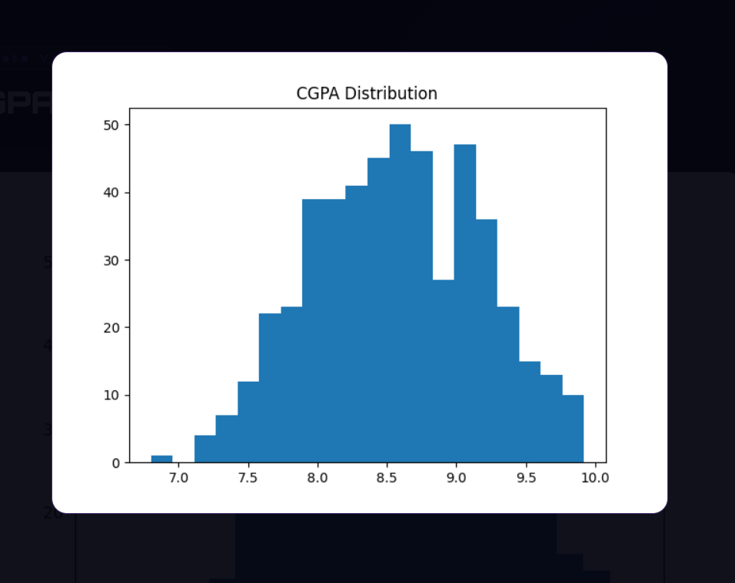

CGPA Distribution (Histogram):

The CGPA distribution shows that most applicants fall between 8.0 and 9.2, with the highest concentration peaking around 8.5 to 8.7. The distribution is roughly bell-shaped but slightly right-skewed, meaning there are more applicants on the higher end than the lower end. Very few students fall below 7.0, indicating this is a highly competitive and academically strong applicant pool. The narrow spread around 8.5 also means that even small differences in CGPA — for example, 8.4 vs 8.9 — can significantly impact admission chances, given that CGPA has the highest correlation (0.88) with the target variable.

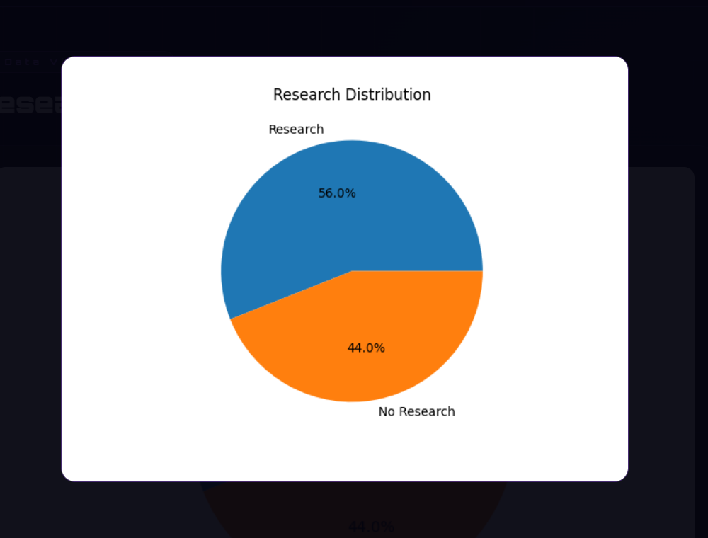

Research Distribution (Pie Chart):

Out of 500 applicants, 56% have research experience and 44% do not. This is a fairly balanced split, meaning research experience is common but not universal in this applicant pool. This matters because research has a 0.55 correlation with admission chances, making it a meaningful differentiator. Applicants with research experience generally have a higher probability of admission compared to those without. The near-equal split also suggests that many strong applicants are admitted even without research, meaning other factors like CGPA and GRE scores can compensate.

ABOUT US PAGE

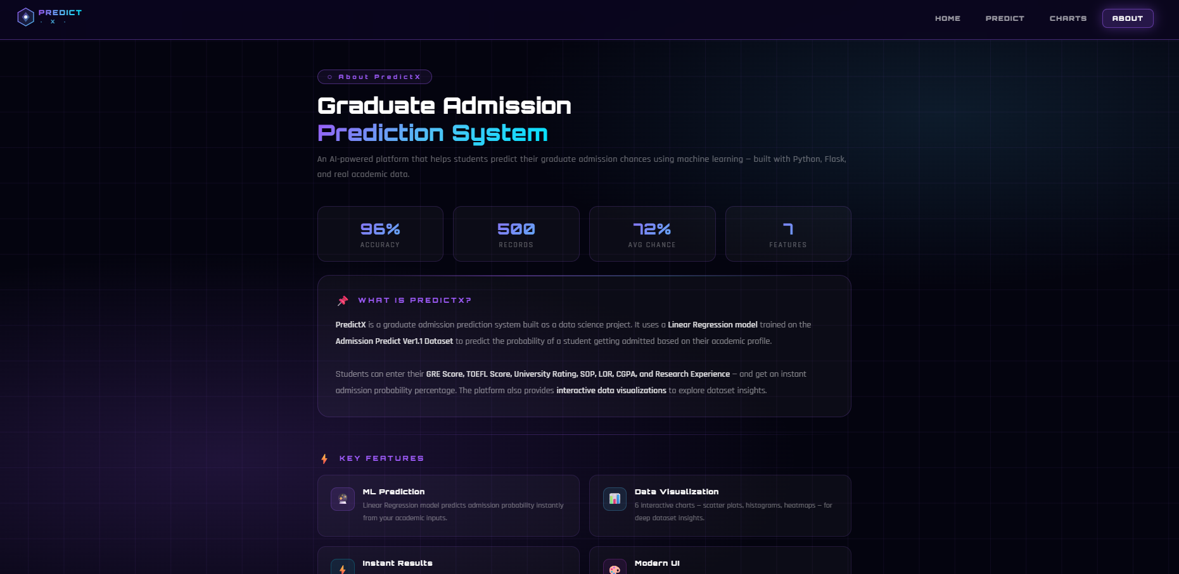

Code:

<!DOCTYPE html>
<html lang="en">
<head>
<meta charset="UTF-8"/>
<meta name="viewport" content="width=device-width, initial-scale=1.0"/>
<title>PredictX — About Us</title>
<style>
@import url('https://fonts.googleapis.com/css2?family=Orbitron:wght@900&family=Rajdhani:wght@400;600&display=swap');
*{margin:0;padding:0;box-sizing:border-box}
body{font-family:'Rajdhani',sans-serif;background:#04040f;color:#fff;min-height:100vh}

/* BG */
body::before{content:'';position:fixed;inset:0;z-index:0;
background:radial-gradient(ellipse 80% 60% at 20% 80%,rgba(155,89,245,.18) 0%,transparent 60%),
radial-gradient(ellipse 60% 50% at 80% 20%,rgba(79,195,247,.12) 0%,transparent 60%),#04040f}
body::after{content:'';position:fixed;inset:0;z-index:0;
background-image:linear-gradient(rgba(155,89,245,.07) 1px,transparent 1px),
linear-gradient(90deg,rgba(155,89,245,.07) 1px,transparent 1px);
background-size:60px 60px;animation:grid 20s linear infinite}
@keyframes grid{to{background-position:60px 60px}}

/* NAVBAR */
nav{position:sticky;top:0;z-index:999;height:70px;display:flex;align-items:center;
justify-content:space-between;padding:0 50px;background:rgba(10,5,30,.9);
backdrop-filter:blur(20px);border-bottom:1px solid rgba(155,89,245,.4)}
nav a{text-decoration:none}
.links{display:flex;gap:8px}
.links a{color:rgba(255,255,255,.6);font-family:'Orbitron',monospace;font-size:11px;
letter-spacing:1.5px;text-transform:uppercase;padding:8px 16px;border-radius:8px;
border:1px solid transparent;transition:all .3s}
.links a:hover{color:#fff;background:rgba(155,89,245,.15);border-color:rgba(155,89,245,.4)}
.links a.on{color:#fff;background:rgba(155,89,245,.2);border-color:rgba(155,89,245,.5);
box-shadow:0 0 20px rgba(155,89,245,.4)}

/* MAIN */
main{position:relative;z-index:1;max-width:960px;margin:0 auto;padding:50px 30px 70px;
animation:up .8s ease both}
@keyframes up{from{opacity:0;transform:translateY(30px)}to{opacity:1;transform:translateY(0)}}

/* TAG & HEADING */
.tag{display:inline-block;font-family:'Orbitron',monospace;font-size:10px;letter-spacing:4px;
color:#9b59f5;border:1px solid rgba(155,89,245,.4);padding:5px 16px;border-radius:20px;
background:rgba(155,89,245,.08);margin-bottom:14px}
h1{font-family:'Orbitron',monospace;font-size:clamp(24px,3vw,38px);font-weight:900;
line-height:1.2;margin-bottom:10px}
h1 span{background:linear-gradient(135deg,#9b59f5,#4fc3f7,#00e5ff);
-webkit-background-clip:text;-webkit-text-fill-color:transparent;background-clip:text}
.subtitle{font-size:15px;color:rgba(255,255,255,.4);margin-bottom:40px;letter-spacing:.5px;line-height:1.7}

/* GLASS CARD */
.card{background:rgba(255,255,255,.03);border:1px solid rgba(155,89,245,.2);
border-radius:20px;padding:30px;margin-bottom:22px;position:relative;overflow:hidden}
.card::before{content:'';position:absolute;top:0;left:10%;right:10%;height:1px;
background:linear-gradient(90deg,transparent,rgba(155,89,245,.6),rgba(79,195,247,.4),transparent)}

.card-title{font-family:'Orbitron',monospace;font-size:12px;letter-spacing:3px;
color:#9b59f5;text-transform:uppercase;margin-bottom:16px;
display:flex;align-items:center;gap:10px}
.card-title span{font-size:18px}
.card p{font-size:15px;color:rgba(255,255,255,.5);line-height:1.85}
.card p strong{color:rgba(255,255,255,.85)}

/* STATS ROW */
.stats{display:grid;grid-template-columns:repeat(4,1fr);gap:16px;margin-bottom:22px}
.stat{background:rgba(255,255,255,.03);border:1px solid rgba(155,89,245,.18);
border-radius:14px;padding:20px;text-align:center;transition:all .3s}
.stat:hover{border-color:rgba(155,89,245,.4);background:rgba(155,89,245,.07)}
.stat-val{font-family:'Orbitron',monospace;font-size:26px;font-weight:900;
background:linear-gradient(135deg,#9b59f5,#4fc3f7);
-webkit-background-clip:text;-webkit-text-fill-color:transparent;background-clip:text}
.stat-label{font-size:12px;color:rgba(255,255,255,.35);letter-spacing:2px;
text-transform:uppercase;margin-top:4px}

/* FEATURES GRID */
.features{display:grid;grid-template-columns:1fr 1fr;gap:16px;margin-bottom:22px}
.feat{background:rgba(255,255,255,.03);border:1px solid rgba(155,89,245,.15);
border-radius:14px;padding:20px 22px;display:flex;gap:14px;align-items:flex-start;transition:all .3s}
.feat:hover{border-color:rgba(155,89,245,.35);background:rgba(155,89,245,.06)}
.feat-icon{width:40px;height:40px;border-radius:10px;display:flex;align-items:center;
justify-content:center;font-size:18px;flex-shrink:0;
background:rgba(155,89,245,.12);border:1px solid rgba(155,89,245,.25)}
.feat-icon.blue{background:rgba(79,195,247,.1);border-color:rgba(79,195,247,.25)}
.feat-icon.cyan{background:rgba(0,229,255,.08);border-color:rgba(0,229,255,.2)}
.feat-icon.pink{background:rgba(224,64,251,.08);border-color:rgba(224,64,251,.2)}
.feat h3{font-family:'Orbitron',monospace;font-size:12px;font-weight:700;
letter-spacing:1px;margin-bottom:6px}
.feat p{font-size:13px;color:rgba(255,255,255,.4);line-height:1.6}

/* TECH STACK */
.tech-row{display:flex;flex-wrap:wrap;gap:10px;margin-top:14px}
.tech-pill{font-family:'Orbitron',monospace;font-size:9px;letter-spacing:2px;
padding:6px 14px;border-radius:20px;text-transform:uppercase}
.tp1{background:rgba(155,89,245,.12);color:#9b59f5;border:1px solid rgba(155,89,245,.3)}
.tp2{background:rgba(79,195,247,.1);color:#4fc3f7;border:1px solid rgba(79,195,247,.3)}
.tp3{background:rgba(0,229,255,.08);color:#00e5ff;border:1px solid rgba(0,229,255,.25)}
.tp4{background:rgba(224,64,251,.08);color:#e040fb;border:1px solid rgba(224,64,251,.2)}
.tp5{background:rgba(0,229,129,.08);color:#00e581;border:1px solid rgba(0,229,129,.25)}

/* TEAM CARD */
.team{display:grid;grid-template-columns:repeat(auto-fit,minmax(200px,1fr));gap:16px;margin-bottom:22px}
.member{background:rgba(255,255,255,.03);border:1px solid rgba(155,89,245,.15);
border-radius:16px;padding:24px;text-align:center;transition:all .3s}
.member:hover{border-color:rgba(155,89,245,.4);transform:translateY(-4px)}
.avatar{width:64px;height:64px;border-radius:50%;margin:0 auto 14px;
background:linear-gradient(135deg,#9b59f5,#4fc3f7);
display:flex;align-items:center;justify-content:center;font-size:26px;
border:2px solid rgba(155,89,245,.4);box-shadow:0 0 20px rgba(155,89,245,.25)}
.member h3{font-family:'Orbitron',monospace;font-size:12px;font-weight:700;
letter-spacing:1px;margin-bottom:6px}
.member p{font-size:12px;color:rgba(255,255,255,.4);letter-spacing:.5px}
.member-role{display:inline-block;margin-top:10px;font-family:'Orbitron',monospace;
font-size:8px;letter-spacing:2px;color:#9b59f5;
border:1px solid rgba(155,89,245,.3);padding:4px 10px;border-radius:10px;
background:rgba(155,89,245,.08)}

/* DIVIDER */
.divider{height:1px;background:linear-gradient(90deg,transparent,rgba(155,89,245,.3),transparent);margin:28px 0}

/* CTA */
.cta{display:flex;gap:14px;flex-wrap:wrap;margin-top:10px}
.btn-primary{display:inline-flex;align-items:center;gap:8px;padding:13px 28px;
border-radius:10px;border:none;background:linear-gradient(135deg,#7b2ff7,#4b0aab);
color:#fff;font-family:'Orbitron',monospace;font-size:11px;letter-spacing:2px;
text-decoration:none;box-shadow:0 0 25px rgba(155,89,245,.4);transition:all .3s}
.btn-primary:hover{transform:translateY(-2px);box-shadow:0 0 40px rgba(155,89,245,.6)}
.btn-outline{display:inline-flex;align-items:center;gap:8px;padding:12px 26px;
border-radius:10px;border:1px solid rgba(79,195,247,.4);
background:rgba(79,195,247,.08);color:#4fc3f7;font-family:'Orbitron',monospace;
font-size:11px;letter-spacing:2px;text-decoration:none;transition:all .3s}
.btn-outline:hover{background:rgba(79,195,247,.18);box-shadow:0 0 20px rgba(79,195,247,.4);transform:translateY(-2px)}

footer{text-align:center;padding:26px;border-top:1px solid rgba(155,89,245,.1);
color:rgba(255,255,255,.2);font-size:11px;letter-spacing:2px;
font-family:'Orbitron',monospace;position:relative;z-index:1}

@media(max-width:768px){
nav{padding:0 20px}.links{display:none}
main{padding:30px 18px 50px}
.stats{grid-template-columns:repeat(2,1fr)}
.features{grid-template-columns:1fr}
}
</style>
</head>
<body>

<nav>
<a href="/">
<svg width="150" height="36" viewBox="0 0 160 38" fill="none">
<defs>
<linearGradient id="hg" x1="0" y1="0" x2="1" y2="1"><stop offset="0%" stop-color="#9b59f5"/><stop offset="100%" stop-color="#4fc3f7"/></linearGradient>
<linearGradient id="tg" x1="0" y1="0" x2="1" y2="0"><stop offset="0%" stop-color="#9b59f5"/><stop offset="60%" stop-color="#4fc3f7"/><stop offset="100%" stop-color="#00e5ff"/></linearGradient>
</defs>
<polygon points="19,3 33,11 33,27 19,35 5,27 5,11" fill="url(#hg)" opacity=".15"/>
<polygon points="19,3 33,11 33,27 19,35 5,27 5,11" fill="none" stroke="url(#hg)" stroke-width="1.5"/>
<polygon points="19,10 26,19 19,28 12,19" fill="url(#hg)" opacity=".5"/>
<circle cx="19" cy="19" r="3" fill="white" opacity=".9"/>
<text x="42" y="16" font-family="Orbitron,monospace" font-size="13" font-weight="900" fill="url(#tg)" letter-spacing="2">PREDICT</text>
<text x="44" y="31" font-family="Orbitron,monospace" font-size="9" fill="#4fc3f7" letter-spacing="6" opacity=".8">· X ·</text>
<line x1="42" y1="19" x2="152" y2="19" stroke="url(#tg)" stroke-width=".5" opacity=".4"/>
</svg>
</a>
<div class="links">
<a href="/">Home</a>
<a href="/predict_page">Predict</a>
<a href="/charts">Charts</a>
<a href="/about" class="on">About</a>
</div>
</nav>

<main>

<!-- HERO -->
<div class="tag">⬡ About PredictX</div>
<h1>Graduate Admission<br><span>Prediction System</span></h1>
<p class="subtitle">An AI-powered platform that helps students predict their graduate admission chances using machine learning — built with Python, Flask, and real academic data.</p>

<!-- STATS -->
<div class="stats">
<div class="stat">
<div class="stat-val">96%</div>
<div class="stat-label">Accuracy</div>
</div>
<div class="stat">
<div class="stat-val">500</div>
<div class="stat-label">Records</div>
</div>
<div class="stat">
<div class="stat-val">72%</div>
<div class="stat-label">Avg Chance</div>
</div>
<div class="stat">
<div class="stat-val">7</div>
<div class="stat-label">Features</div>
</div>
</div>

<!-- ABOUT -->
<div class="card">
<div class="card-title"><span>📌</span> What is PredictX?</div>
<p>
<strong>PredictX</strong> is a graduate admission prediction system built as a data science project.
It uses a <strong>Linear Regression model</strong> trained on the <strong>Admission Predict Ver1.1 Dataset</strong>
to predict the probability of a student getting admitted based on their academic profile.<br><br>
Students can enter their <strong>GRE Score, TOEFL Score, University Rating, SOP, LOR, CGPA,
and Research Experience</strong> — and get an instant admission probability percentage.
The platform also provides <strong>interactive data visualizations</strong> to explore dataset insights.
</p>
</div>

<div class="divider"></div>

<!-- FEATURES -->
<div class="card-title" style="margin-bottom:16px"><span>⚡</span> Key Features</div>
<div class="features">
<div class="feat">
<div class="feat-icon">🔮</div>
<div>
<h3>ML Prediction</h3>
<p>Linear Regression model predicts admission probability instantly from your academic inputs.</p>
</div>
</div>
<div class="feat">
<div class="feat-icon blue">📊</div>
<div>
<h3>Data Visualization</h3>
<p>6 interactive charts — scatter plots, histograms, heatmaps — for deep dataset insights.</p>
</div>
</div>
<div class="feat">
<div class="feat-icon cyan">⚡</div>
<div>
<h3>Instant Results</h3>
<p>Real-time prediction output with percentage score and admission status label.</p>
</div>
</div>
<div class="feat">
<div class="feat-icon pink">🎨</div>
<div>
<h3>Modern UI</h3>
<p>Cyberpunk-themed glassmorphism interface with smooth animations across all pages.</p>
</div>
</div>
</div>

<div class="divider"></div>

<!-- TECH STACK -->
<div class="card">
<div class="card-title"><span>🛠️</span> Tech Stack</div>
<p>This project is built using the following technologies:</p>
<div class="tech-row">
<span class="tech-pill tp1">Python</span>
<span class="tech-pill tp2">Flask</span>
<span class="tech-pill tp1">Scikit-Learn</span>
<span class="tech-pill tp3">Pandas</span>
<span class="tech-pill tp4">Matplotlib</span>
<span class="tech-pill tp5">Seaborn</span>
<span class="tech-pill tp2">HTML / CSS</span>
<span class="tech-pill tp1">NumPy</span>
</div>
</div>

<div class="divider"></div>

<!-- DATASET -->
<div class="card">
<div class="card-title"><span>🗂️</span> Dataset</div>
<p>
The model is trained on the <strong>Admission Predict Ver1.1 Dataset</strong> which contains
<strong>500 student records</strong> with 8 columns including the target variable.<br><br>
<strong>GRE Score</strong> (290–340) &nbsp;·&nbsp;
<strong>TOEFL Score</strong> (92–120) &nbsp;·&nbsp;
<strong>University Rating</strong> (1–5) &nbsp;·&nbsp;
<strong>SOP Strength</strong> (1–5) &nbsp;·&nbsp;
<strong>LOR Strength</strong> (1–5) &nbsp;·&nbsp;
<strong>CGPA</strong> (6.8–9.92) &nbsp;·&nbsp;
<strong>Research</strong> (0 or 1) &nbsp;·&nbsp;
<strong>Chance of Admit</strong> (0.34–0.97)<br><br>
Out of 500 students, <strong>280 have research experience</strong> and <strong>220 do not</strong>.
The average admission chance in the dataset is <strong>72%</strong>.
</p>
</div>

<div class="divider"></div>

<!-- TEAM -->
<div class="card-title" style="margin-bottom:16px"><span>👨‍💻</span> Developer</div>
<div class="team">
<div class="member">
<div class="avatar">👨‍💻</div>
<h3>Shahil Pathan</h3>
<p>BCA — Computer Application</p>
<div class="member-role">ML Developer</div>
</div>
<div class="member">
<div class="avatar">🎓</div>
<h3>Dr. Darshna Rajput</h3>
<p>Project Guide & Supervisor</p>
<div class="member-role">Supervisor</div>
</div>
<div class="member">
<div class="avatar">🏛️</div>
<h3>Dolat-Usha Institute</h3>
<p>of Engineering & Technology</p>
<div class="member-role">Academic Project</div>
</div>
</div>

<div class="divider"></div>

<!-- CTA -->
<div class="cta">
<a href="/predict_page" class="btn-primary">🔮 Try Prediction</a>
<a href="/charts" class="btn-outline">📊 View Charts</a>
</div>

</main>

<footer>⬡ PREDICTX &nbsp;·&nbsp; GRADUATE ADMISSION PREDICTION &nbsp;·&nbsp; BUILT WITH FLASK</footer>

</body>
</html>

DATASET PAGE

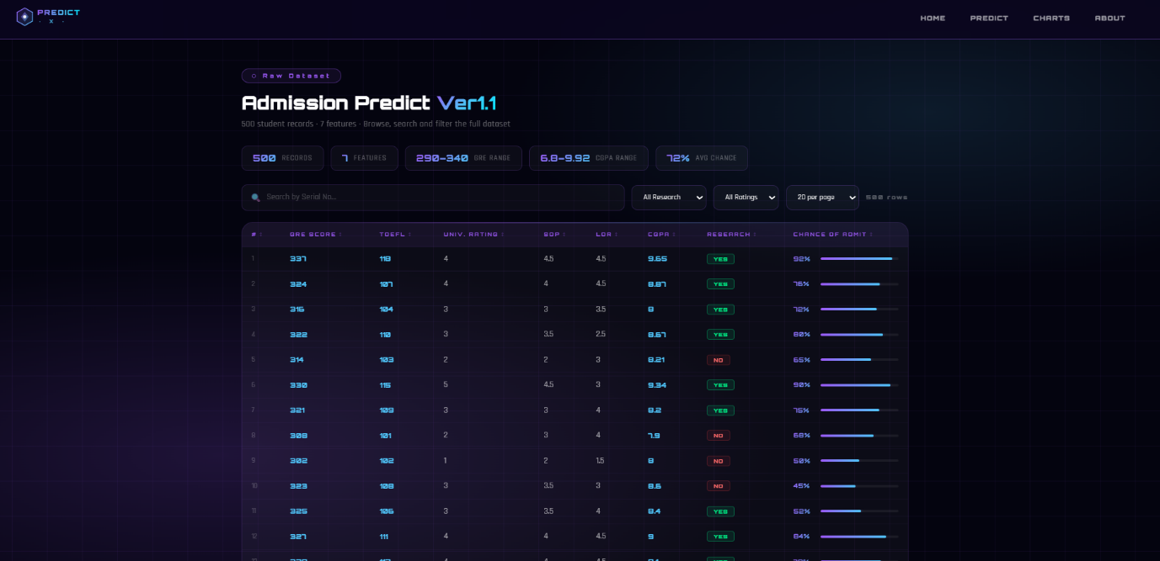

Code:

<!DOCTYPE html>
<html lang="en">
<head>
<meta charset="UTF-8"/>
<meta name="viewport" content="width=device-width, initial-scale=1.0"/>
<title>PredictX — Dataset</title>
<style>
@import url('https://fonts.googleapis.com/css2?family=Orbitron:wght@900&family=Rajdhani:wght@400;600&display=swap');
*{margin:0;padding:0;box-sizing:border-box}
body{font-family:'Rajdhani',sans-serif;background:#04040f;color:#fff;min-height:100vh}

/* BG */
body::before{content:'';position:fixed;inset:0;z-index:0;
background:radial-gradient(ellipse 80% 60% at 20% 80%,rgba(155,89,245,.18) 0%,transparent 60%),
radial-gradient(ellipse 60% 50% at 80% 20%,rgba(79,195,247,.12) 0%,transparent 60%),#04040f}
body::after{content:'';position:fixed;inset:0;z-index:0;
background-image:linear-gradient(rgba(155,89,245,.07) 1px,transparent 1px),
linear-gradient(90deg,rgba(155,89,245,.07) 1px,transparent 1px);
background-size:60px 60px;animation:grid 20s linear infinite}
@keyframes grid{to{background-position:60px 60px}}

/* NAVBAR */
nav{position:sticky;top:0;z-index:999;height:70px;display:flex;align-items:center;
justify-content:space-between;padding:0 50px;background:rgba(10,5,30,.9);
backdrop-filter:blur(20px);border-bottom:1px solid rgba(155,89,245,.4)}
nav a{text-decoration:none}
.links{display:flex;gap:8px}
.links a{color:rgba(255,255,255,.6);font-family:'Orbitron',monospace;font-size:11px;
letter-spacing:1.5px;text-transform:uppercase;padding:8px 16px;border-radius:8px;
border:1px solid transparent;transition:all .3s}
.links a:hover{color:#fff;background:rgba(155,89,245,.15);border-color:rgba(155,89,245,.4)}
.links a.on{color:#fff;background:rgba(155,89,245,.2);border-color:rgba(155,89,245,.5);
box-shadow:0 0 20px rgba(155,89,245,.4)}

/* MAIN */
main{position:relative;z-index:1;max-width:1200px;margin:0 auto;padding:50px 30px 60px;
animation:up .8s ease both}
@keyframes up{from{opacity:0;transform:translateY(30px)}to{opacity:1;transform:translateY(0)}}

/* HEADER */
.tag{display:inline-block;font-family:'Orbitron',monospace;font-size:10px;letter-spacing:4px;
color:#9b59f5;border:1px solid rgba(155,89,245,.4);padding:5px 16px;border-radius:20px;
background:rgba(155,89,245,.08);margin-bottom:14px}
h1{font-family:'Orbitron',monospace;font-size:clamp(22px,3vw,32px);font-weight:900;margin-bottom:8px}
h1 span{background:linear-gradient(135deg,#9b59f5,#4fc3f7,#00e5ff);
-webkit-background-clip:text;-webkit-text-fill-color:transparent;background-clip:text}
.sub{font-size:14px;color:rgba(255,255,255,.4);margin-bottom:28px;letter-spacing:.5px}

/* STATS CHIPS */
.chips{display:flex;gap:12px;flex-wrap:wrap;margin-bottom:24px}
.chip{background:rgba(255,255,255,.03);border:1px solid rgba(155,89,245,.18);
border-radius:10px;padding:10px 18px;display:flex;align-items:center;gap:10px}
.chip-val{font-family:'Orbitron',monospace;font-size:16px;font-weight:900;
background:linear-gradient(135deg,#9b59f5,#4fc3f7);
-webkit-background-clip:text;-webkit-text-fill-color:transparent;background-clip:text}
.chip-label{font-size:12px;color:rgba(255,255,255,.35);letter-spacing:1px;text-transform:uppercase}

/* SEARCH & FILTER */
.controls{display:flex;gap:12px;margin-bottom:20px;flex-wrap:wrap;align-items:center}
.search-wrap{position:relative;flex:1;min-width:200px}
.search-wrap input{
width:100%;padding:12px 16px 12px 42px;
background:rgba(255,255,255,.03);
border:1px solid rgba(155,89,245,.2);
border-radius:10px;color:#fff;
font-family:'Rajdhani',sans-serif;font-size:14px;
outline:none;transition:all .3s}
.search-wrap input:focus{border-color:rgba(155,89,245,.5);background:rgba(155,89,245,.05);
box-shadow:0 0 0 3px rgba(155,89,245,.1)}
.search-wrap input::placeholder{color:rgba(255,255,255,.25)}
.search-icon{position:absolute;left:14px;top:50%;transform:translateY(-50%);
color:rgba(155,89,245,.6);font-size:15px}

.filter-select{
padding:12px 16px;background:rgba(255,255,255,.03);
border:1px solid rgba(155,89,245,.2);border-radius:10px;
color:#fff;font-family:'Rajdhani',monospace;font-size:13px;
outline:none;cursor:pointer;transition:all .3s}
.filter-select:focus{border-color:rgba(155,89,245,.5)}
.filter-select option{background:#0d0920}

.rows-label{font-family:'Orbitron',monospace;font-size:10px;letter-spacing:2px;
color:rgba(255,255,255,.3);white-space:nowrap;align-self:center}

/* TABLE CARD */
.table-card{background:rgba(255,255,255,.03);border:1px solid rgba(155,89,245,.2);
border-radius:20px;overflow:hidden;position:relative;margin-bottom:20px}
.table-card::before{content:'';position:absolute;top:0;left:10%;right:10%;height:1px;
background:linear-gradient(90deg,transparent,rgba(155,89,245,.6),rgba(79,195,247,.4),transparent)}

.table-wrap{overflow-x:auto}
table{width:100%;border-collapse:collapse;min-width:800px}

thead tr{background:rgba(155,89,245,.08);border-bottom:1px solid rgba(155,89,245,.2)}
thead th{
font-family:'Orbitron',monospace;font-size:9px;letter-spacing:2px;
color:rgba(155,89,245,.9);text-transform:uppercase;
padding:14px 16px;text-align:left;white-space:nowrap;
cursor:pointer;user-select:none;transition:color .2s}
thead th:hover{color:#fff}
thead th .sort-icon{margin-left:4px;opacity:.4;font-size:10px}
thead th.sorted .sort-icon{opacity:1;color:#9b59f5}

tbody tr{border-bottom:1px solid rgba(155,89,245,.06);transition:background .2s}
tbody tr:hover{background:rgba(155,89,245,.06)}
tbody tr:last-child{border-bottom:none}
tbody td{padding:12px 16px;font-size:14px;color:rgba(255,255,255,.65);white-space:nowrap}

/* special column styles */
.col-serial{color:rgba(255,255,255,.25);font-size:12px}
.col-gre,.col-toefl,.col-cgpa{
font-family:'Orbitron',monospace;font-size:12px;font-weight:900;
color:#4fc3f7}
.col-research-yes{display:inline-block;padding:2px 10px;border-radius:4px;
background:rgba(0,229,129,.1);color:#00e581;border:1px solid rgba(0,229,129,.3);
font-family:'Orbitron',monospace;font-size:9px;letter-spacing:1px}
.col-research-no{display:inline-block;padding:2px 10px;border-radius:4px;
background:rgba(255,65,65,.08);color:#ff6b6b;border:1px solid rgba(255,65,65,.2);
font-family:'Orbitron',monospace;font-size:9px;letter-spacing:1px}

/* chance bar */
.chance-wrap{display:flex;align-items:center;gap:8px}
.chance-val{font-family:'Orbitron',monospace;font-size:11px;font-weight:900;
background:linear-gradient(135deg,#9b59f5,#4fc3f7);
-webkit-background-clip:text;-webkit-text-fill-color:transparent;
background-clip:text;min-width:38px}
.chance-bar{flex:1;height:4px;background:rgba(255,255,255,.06);border-radius:4px;overflow:hidden;min-width:60px}
.chance-fill{height:100%;border-radius:4px;
background:linear-gradient(90deg,#9b59f5,#4fc3f7);
box-shadow:0 0 6px rgba(155,89,245,.4)}

/* PAGINATION */
.pagination{display:flex;align-items:center;justify-content:space-between;
padding:16px 20px;border-top:1px solid rgba(155,89,245,.1);flex-wrap:wrap;gap:12px}
.page-info{font-size:13px;color:rgba(255,255,255,.35);font-family:'Orbitron',monospace;
font-size:10px;letter-spacing:1px}
.page-btns{display:flex;gap:6px}
.page-btn{padding:7px 14px;border-radius:8px;border:1px solid rgba(155,89,245,.25);
background:rgba(155,89,245,.06);color:rgba(255,255,255,.6);
font-family:'Orbitron',monospace;font-size:10px;letter-spacing:1px;
cursor:pointer;transition:all .3s}
.page-btn:hover{background:rgba(155,89,245,.18);border-color:rgba(155,89,245,.5);color:#fff}
.page-btn.active{background:rgba(155,89,245,.25);border-color:rgba(155,89,245,.6);color:#fff;
box-shadow:0 0 12px rgba(155,89,245,.3)}
.page-btn:disabled{opacity:.3;cursor:not-allowed}

/* back btn */
.back{display:inline-flex;align-items:center;gap:8px;font-family:'Orbitron',monospace;
font-size:10px;letter-spacing:2px;text-transform:uppercase;color:rgba(255,255,255,.6);
text-decoration:none;border:1px solid rgba(155,89,245,.3);padding:11px 22px;
border-radius:10px;background:rgba(155,89,245,.07);transition:all .3s;margin-top:8px;display:inline-flex}
.back:hover{color:#fff;background:rgba(155,89,245,.18);border-color:rgba(155,89,245,.6);
box-shadow:0 0 20px rgba(155,89,245,.3);transform:translateY(-2px)}

footer{text-align:center;padding:26px;border-top:1px solid rgba(155,89,245,.1);
color:rgba(255,255,255,.2);font-size:11px;letter-spacing:2px;
font-family:'Orbitron',monospace;position:relative;z-index:1}

@media(max-width:768px){
nav{padding:0 20px}.links{display:none}
main{padding:30px 16px 50px}
.chips{gap:8px}
}
</style>
</head>
<body>

<nav>
<a href="/">
<svg width="150" height="36" viewBox="0 0 160 38" fill="none">
<defs>
<linearGradient id="hg" x1="0" y1="0" x2="1" y2="1"><stop offset="0%" stop-color="#9b59f5"/><stop offset="100%" stop-color="#4fc3f7"/></linearGradient>
<linearGradient id="tg" x1="0" y1="0" x2="1" y2="0"><stop offset="0%" stop-color="#9b59f5"/><stop offset="60%" stop-color="#4fc3f7"/><stop offset="100%" stop-color="#00e5ff"/></linearGradient>
</defs>
<polygon points="19,3 33,11 33,27 19,35 5,27 5,11" fill="url(#hg)" opacity=".15"/>
<polygon points="19,3 33,11 33,27 19,35 5,27 5,11" fill="none" stroke="url(#hg)" stroke-width="1.5"/>
<polygon points="19,10 26,19 19,28 12,19" fill="url(#hg)" opacity=".5"/>
<circle cx="19" cy="19" r="3" fill="white" opacity=".9"/>
<text x="42" y="16" font-family="Orbitron,monospace" font-size="13" font-weight="900" fill="url(#tg)" letter-spacing="2">PREDICT</text>
<text x="44" y="31" font-family="Orbitron,monospace" font-size="9" fill="#4fc3f7" letter-spacing="6" opacity=".8">· X ·</text>
<line x1="42" y1="19" x2="152" y2="19" stroke="url(#tg)" stroke-width=".5" opacity=".4"/>
</svg>
</a>
<div class="links">
<a href="/">Home</a>
<a href="/predict_page">Predict</a>
<a href="/charts">Charts</a>
<a href="/about">About</a>
</div>
</nav>

<main>

<div class="tag">⬡ Raw Dataset</div>
<h1>Admission Predict <span>Ver1.1</span></h1>
<p class="sub">500 student records · 7 features · Browse, search and filter the full dataset</p>

<!-- STATS CHIPS -->
<div class="chips">
<div class="chip"><div class="chip-val">500</div><div class="chip-label">Records</div></div>
<div class="chip"><div class="chip-val">7</div><div class="chip-label">Features</div></div>
<div class="chip"><div class="chip-val">290–340</div><div class="chip-label">GRE Range</div></div>
<div class="chip"><div class="chip-val">6.8–9.92</div><div class="chip-label">CGPA Range</div></div>
<div class="chip"><div class="chip-val">72%</div><div class="chip-label">Avg Chance</div></div>
</div>

<!-- CONTROLS -->
<div class="controls">
<div class="search-wrap">
<span class="search-icon">🔍</span>
<input type="number" id="searchInput" placeholder="Search by Serial No..." oninput="filterTable()"/>
</div>
<select class="filter-select" id="researchFilter" onchange="filterTable()">
<option value="">All Research</option>
<option value="1">Has Research</option>
<option value="0">No Research</option>
</select>
<select class="filter-select" id="ratingFilter" onchange="filterTable()">
<option value="">All Ratings</option>
<option value="1">Rating 1</option>
<option value="2">Rating 2</option>
<option value="3">Rating 3</option>
<option value="4">Rating 4</option>
<option value="5">Rating 5</option>
</select>
<select class="filter-select" id="perPage" onchange="changePerPage()">
<option value="20">20 per page</option>
<option value="50">50 per page</option>
<option value="100">100 per page</option>
</select>
<span class="rows-label" id="rowsLabel">500 rows</span>
</div>

<!-- TABLE -->
<div class="table-card">
<div class="table-wrap">
<table id="dataTable">
<thead>
<tr>
<th onclick="sortTable(0)" id="th0">#<span class="sort-icon">↕</span></th>
<th onclick="sortTable(1)" id="th1">GRE Score<span class="sort-icon">↕</span></th>
<th onclick="sortTable(2)" id="th2">TOEFL<span class="sort-icon">↕</span></th>
<th onclick="sortTable(3)" id="th3">Univ. Rating<span class="sort-icon">↕</span></th>
<th onclick="sortTable(4)" id="th4">SOP<span class="sort-icon">↕</span></th>
<th onclick="sortTable(5)" id="th5">LOR<span class="sort-icon">↕</span></th>
<th onclick="sortTable(6)" id="th6">CGPA<span class="sort-icon">↕</span></th>
<th onclick="sortTable(7)" id="th7">Research<span class="sort-icon">↕</span></th>
<th onclick="sortTable(8)" id="th8">Chance of Admit<span class="sort-icon">↕</span></th>
</tr>
</thead>
<tbody id="tableBody"></tbody>
</table>
</div>
<div class="pagination">
<span class="page-info" id="pageInfo">Showing 1–20 of 500</span>
<div class="page-btns" id="pageBtns"></div>
</div>
</div>

<a href="/" class="back">← Back to Home</a>

</main>

<footer>⬡ PREDICTX &nbsp;·&nbsp; ADMISSION PREDICT VER1.1 &nbsp;·&nbsp; 500 RECORDS</footer>

{# Jinja2 data — hidden, no VS Code JS error #}
<script id="dataset-json" type="application/json">{{ dataset | tojson }}</script>

<script>
// ── DATA injected by Flask ──
const RAW_DATA = JSON.parse(document.getElementById('dataset-json').textContent);

let filtered = [...RAW_DATA];
let currentPage = 1;
let perPage = 20;
let sortCol = -1;
let sortAsc = true;

function renderTable() {
const start = (currentPage - 1) * perPage;
const end = start + perPage;
const pageData = filtered.slice(start, end);
const tbody = document.getElementById('tableBody');

tbody.innerHTML = pageData.map(r => `
<tr>
<td class="col-serial">${r[0]}</td>
<td class="col-gre">${r[1]}</td>
<td class="col-toefl">${r[2]}</td>
<td>${r[3]}</td>
<td>${r[4]}</td>
<td>${r[5]}</td>
<td class="col-cgpa">${r[6]}</td>
<td><span class="${r[7]==1?'col-research-yes':'col-research-no'}">${r[7]==1?'YES':'NO'}</span></td>
<td>
<div class="chance-wrap">
<span class="chance-val">${(r[8]*100).toFixed(0)}%</span>
<div class="chance-bar"><div class="chance-fill" style="width:${r[8]*100}%"></div></div>
</div>
</td>
</tr>`).join('');

document.getElementById('rowsLabel').textContent = filtered.length + ' rows';
document.getElementById('pageInfo').textContent =
`Showing ${start+1}–${Math.min(end, filtered.length)} of ${filtered.length}`;
renderPagination();
}

function renderPagination() {
const total = Math.ceil(filtered.length / perPage);
const btns = document.getElementById('pageBtns');
let html = `<button class="page-btn" onclick="goPage(${currentPage-1})" ${currentPage===1?'disabled':''}>←</button>`;
const start = Math.max(1, currentPage-2);
const end = Math.min(total, currentPage+2);
if(start > 1) html += `<button class="page-btn" onclick="goPage(1)">1</button>${start>2?'<span style="color:rgba(255,255,255,.2);padding:0 4px">…</span>':''}`;
for(let i=start;i<=end;i++)
html += `<button class="page-btn ${i===currentPage?'active':''}" onclick="goPage(${i})">${i}</button>`;
if(end < total) html += `${end<total-1?'<span style="color:rgba(255,255,255,.2);padding:0 4px">…</span>':''}<button class="page-btn" onclick="goPage(${total})">${total}</button>`;
html += `<button class="page-btn" onclick="goPage(${currentPage+1})" ${currentPage===total?'disabled':''}>→</button>`;
btns.innerHTML = html;
}

function goPage(p) {
const total = Math.ceil(filtered.length / perPage);
if(p < 1 || p > total) return;
currentPage = p;
renderTable();
window.scrollTo({top:0,behavior:'smooth'});
}

function filterTable() {
const search = document.getElementById('searchInput').value.trim();
const research = document.getElementById('researchFilter').value;
const rating = document.getElementById('ratingFilter').value;
filtered = RAW_DATA.filter(r => {
if(search && !String(r[0]).includes(search)) return false;
if(research !== '' && String(r[7]) !== research) return false;
if(rating !== '' && String(r[3]) !== rating) return false;
return true;
});
currentPage = 1;
renderTable();
}

function changePerPage() {
perPage = parseInt(document.getElementById('perPage').value);
currentPage = 1;
renderTable();
}

function sortTable(col) {
if(sortCol === col) sortAsc = !sortAsc;
else { sortCol = col; sortAsc = true; }
document.querySelectorAll('thead th').forEach((th,i) => {
th.classList.toggle('sorted', i===col);
th.querySelector('.sort-icon').textContent = i===col ? (sortAsc?'↑':'↓') : '↕';
});
filtered.sort((a,b) => {
const va = isNaN(a[col]) ? a[col] : Number(a[col]);
const vb = isNaN(b[col]) ? b[col] : Number(b[col]);
return sortAsc ? (va>vb?1:-1) : (va<vb?1:-1);
});
currentPage = 1;
renderTable();
}

renderTable();
</script>
</body>
</html>

MODEL PAGE

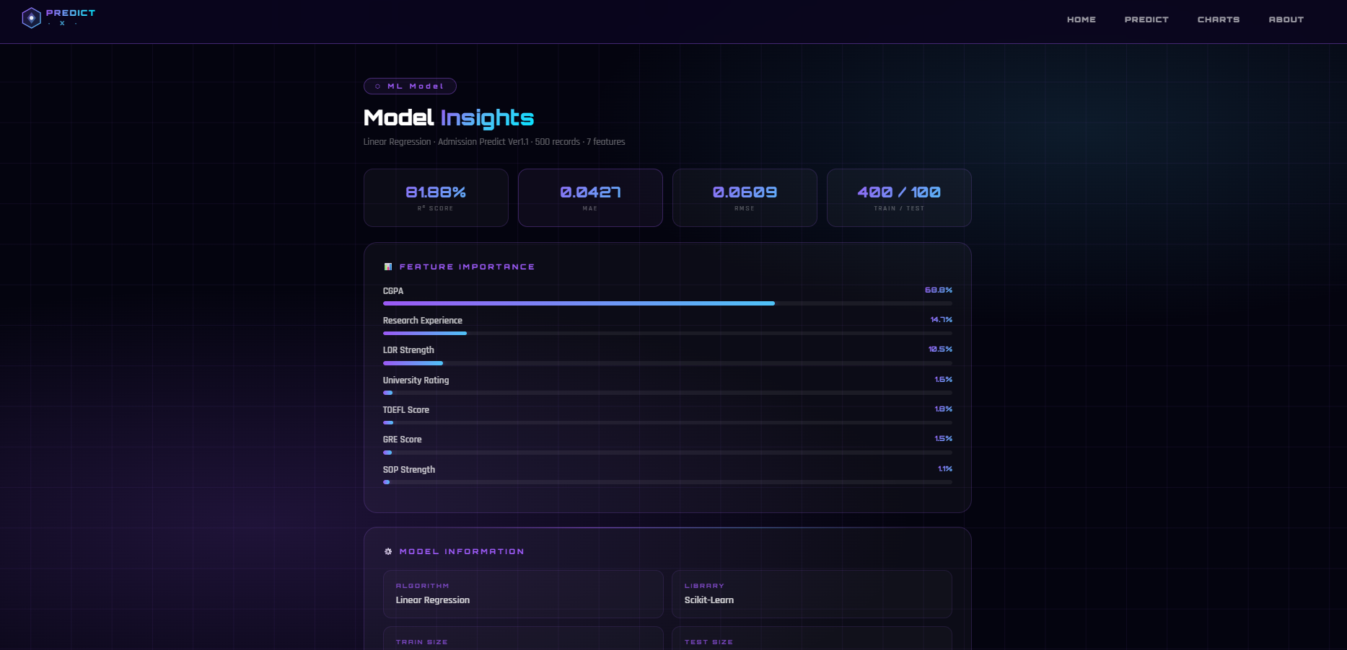

Code:

<!DOCTYPE html>
<html lang="en">
<head>
<meta charset="UTF-8"/>
<meta name="viewport" content="width=device-width, initial-scale=1.0"/>
<title>PredictX — Model Insights</title>
<style>
@import url('https://fonts.googleapis.com/css2?family=Orbitron:wght@900&family=Rajdhani:wght@400;600&display=swap');
*{margin:0;padding:0;box-sizing:border-box}
body{font-family:'Rajdhani',sans-serif;background:#04040f;color:#fff;min-height:100vh}

body::before{content:'';position:fixed;inset:0;z-index:0;
background:radial-gradient(ellipse 80% 60% at 20% 80%,rgba(155,89,245,.18) 0%,transparent 60%),
radial-gradient(ellipse 60% 50% at 80% 20%,rgba(79,195,247,.12) 0%,transparent 60%),#04040f}
body::after{content:'';position:fixed;inset:0;z-index:0;
background-image:linear-gradient(rgba(155,89,245,.07) 1px,transparent 1px),
linear-gradient(90deg,rgba(155,89,245,.07) 1px,transparent 1px);
background-size:60px 60px;animation:grid 20s linear infinite}
@keyframes grid{to{background-position:60px 60px}}

/* NAVBAR */
nav{position:sticky;top:0;z-index:999;height:70px;display:flex;align-items:center;
justify-content:space-between;padding:0 50px;background:rgba(10,5,30,.9);
backdrop-filter:blur(20px);border-bottom:1px solid rgba(155,89,245,.4)}
nav a{text-decoration:none}
.links{display:flex;gap:8px}
.links a{color:rgba(255,255,255,.6);font-family:'Orbitron',monospace;font-size:11px;
letter-spacing:1.5px;text-transform:uppercase;padding:8px 16px;border-radius:8px;
border:1px solid transparent;transition:all .3s}
.links a:hover{color:#fff;background:rgba(155,89,245,.15);border-color:rgba(155,89,245,.4)}
.links a.on{color:#fff;background:rgba(155,89,245,.2);border-color:rgba(155,89,245,.5);
box-shadow:0 0 20px rgba(155,89,245,.4)}

main{position:relative;z-index:1;max-width:960px;margin:0 auto;padding:50px 30px 60px;
animation:up .8s ease both}
@keyframes up{from{opacity:0;transform:translateY(30px)}to{opacity:1;transform:translateY(0)}}

.tag{display:inline-block;font-family:'Orbitron',monospace;font-size:10px;letter-spacing:4px;
color:#9b59f5;border:1px solid rgba(155,89,245,.4);padding:5px 16px;border-radius:20px;
background:rgba(155,89,245,.08);margin-bottom:14px}
h1{font-family:'Orbitron',monospace;font-size:clamp(22px,3vw,32px);font-weight:900;margin-bottom:8px}
h1 span{background:linear-gradient(135deg,#9b59f5,#4fc3f7,#00e5ff);
-webkit-background-clip:text;-webkit-text-fill-color:transparent;background-clip:text}
.sub{font-size:14px;color:rgba(255,255,255,.4);margin-bottom:30px}

/* STATS */
.stats{display:grid;grid-template-columns:repeat(4,1fr);gap:14px;margin-bottom:22px}
.stat{background:rgba(255,255,255,.03);border:1px solid rgba(155,89,245,.18);
border-radius:14px;padding:20px;text-align:center;transition:all .3s}
.stat:hover{border-color:rgba(155,89,245,.4);background:rgba(155,89,245,.07)}
.sv{font-family:'Orbitron',monospace;font-size:22px;font-weight:900;
background:linear-gradient(135deg,#9b59f5,#4fc3f7);
-webkit-background-clip:text;-webkit-text-fill-color:transparent;background-clip:text}
.sl{font-size:10px;color:rgba(255,255,255,.35);letter-spacing:2px;text-transform:uppercase;margin-top:4px}

/* CARD */
.card{background:rgba(255,255,255,.03);border:1px solid rgba(155,89,245,.2);
border-radius:20px;padding:28px;margin-bottom:20px;position:relative;overflow:hidden}
.card::before{content:'';position:absolute;top:0;left:10%;right:10%;height:1px;
background:linear-gradient(90deg,transparent,rgba(155,89,245,.6),rgba(79,195,247,.4),transparent)}
.ctitle{font-family:'Orbitron',monospace;font-size:11px;letter-spacing:3px;
color:#9b59f5;text-transform:uppercase;margin-bottom:20px;display:flex;align-items:center;gap:8px}

/* FEATURE IMPORTANCE BARS */
.feat{margin-bottom:14px}
.feat-top{display:flex;justify-content:space-between;margin-bottom:6px}
.fname{font-size:14px;font-weight:600;color:rgba(255,255,255,.75)}
.fval{font-family:'Orbitron',monospace;font-size:11px;font-weight:900;
background:linear-gradient(135deg,#9b59f5,#4fc3f7);
-webkit-background-clip:text;-webkit-text-fill-color:transparent;background-clip:text}
.bar-bg{height:6px;background:rgba(255,255,255,.06);border-radius:4px;overflow:hidden}
.bar-fill{height:100%;border-radius:4px;
background:linear-gradient(90deg,#9b59f5,#4fc3f7);
box-shadow:0 0 8px rgba(155,89,245,.4);
width:0;transition:width 1.2s ease}

/* INFO GRID */
.igrid{display:grid;grid-template-columns:1fr 1fr;gap:12px}
.iitem{background:rgba(255,255,255,.02);border:1px solid rgba(155,89,245,.12);
border-radius:12px;padding:16px 18px;transition:all .3s}
.iitem:hover{border-color:rgba(155,89,245,.3);background:rgba(155,89,245,.05)}
.ilabel{font-family:'Orbitron',monospace;font-size:9px;letter-spacing:2px;
color:rgba(155,89,245,.7);text-transform:uppercase;margin-bottom:6px}
.ival{font-size:15px;color:rgba(255,255,255,.8);font-weight:600}

/* PIPELINE */
.pipeline{display:flex;align-items:center;flex-wrap:wrap;gap:6px;margin-top:4px}
.step{background:rgba(155,89,245,.1);border:1px solid rgba(155,89,245,.25);
border-radius:8px;padding:8px 14px;font-family:'Orbitron',monospace;
font-size:9px;letter-spacing:1.5px;color:rgba(255,255,255,.7)}
.arr{color:rgba(155,89,245,.5);font-size:14px}

/* COEF TABLE */
table{width:100%;border-collapse:collapse;margin-top:4px}
thead th{font-family:'Orbitron',monospace;font-size:9px;letter-spacing:2px;
color:rgba(155,89,245,.8);text-transform:uppercase;padding:10px 12px;
text-align:left;border-bottom:1px solid rgba(155,89,245,.15)}
tbody tr{border-bottom:1px solid rgba(155,89,245,.06);transition:background .2s}
tbody tr:hover{background:rgba(155,89,245,.05)}
tbody td{padding:10px 12px;font-size:14px;color:rgba(255,255,255,.6)}
.pos{color:#00e581}.neg{color:#ff6b6b}
.mono{font-family:'Orbitron',monospace;font-size:11px}

.back{display:inline-flex;align-items:center;gap:8px;font-family:'Orbitron',monospace;
font-size:10px;letter-spacing:2px;text-transform:uppercase;color:rgba(255,255,255,.6);
text-decoration:none;border:1px solid rgba(155,89,245,.3);padding:11px 22px;
border-radius:10px;background:rgba(155,89,245,.07);transition:all .3s;margin-top:8px}
.back:hover{color:#fff;background:rgba(155,89,245,.18);border-color:rgba(155,89,245,.6);
box-shadow:0 0 20px rgba(155,89,245,.3);transform:translateY(-2px)}

footer{text-align:center;padding:26px;border-top:1px solid rgba(155,89,245,.1);
color:rgba(255,255,255,.2);font-size:11px;letter-spacing:2px;
font-family:'Orbitron',monospace;position:relative;z-index:1}

@media(max-width:768px){
nav{padding:0 20px}.links{display:none}
main{padding:30px 16px 50px}
.stats{grid-template-columns:repeat(2,1fr)}
.igrid{grid-template-columns:1fr}
}
</style>
</head>
<body>

<nav>
<a href="/">
<svg width="150" height="36" viewBox="0 0 160 38" fill="none">
<defs>
<linearGradient id="hg" x1="0" y1="0" x2="1" y2="1"><stop offset="0%" stop-color="#9b59f5"/><stop offset="100%" stop-color="#4fc3f7"/></linearGradient>
<linearGradient id="tg" x1="0" y1="0" x2="1" y2="0"><stop offset="0%" stop-color="#9b59f5"/><stop offset="60%" stop-color="#4fc3f7"/><stop offset="100%" stop-color="#00e5ff"/></linearGradient>
</defs>
<polygon points="19,3 33,11 33,27 19,35 5,27 5,11" fill="url(#hg)" opacity=".15"/>
<polygon points="19,3 33,11 33,27 19,35 5,27 5,11" fill="none" stroke="url(#hg)" stroke-width="1.5"/>
<polygon points="19,10 26,19 19,28 12,19" fill="url(#hg)" opacity=".5"/>
<circle cx="19" cy="19" r="3" fill="white" opacity=".9"/>
<text x="42" y="16" font-family="Orbitron,monospace" font-size="13" font-weight="900" fill="url(#tg)" letter-spacing="2">PREDICT</text>
<text x="44" y="31" font-family="Orbitron,monospace" font-size="9" fill="#4fc3f7" letter-spacing="6" opacity=".8">· X ·</text>
<line x1="42" y1="19" x2="152" y2="19" stroke="url(#tg)" stroke-width=".5" opacity=".4"/>
</svg>
</a>
<div class="links">
<a href="/">Home</a>
<a href="/predict_page">Predict</a>
<a href="/charts">Charts</a>
<a href="/about">About</a>
</div>
</nav>

<main>

<div class="tag">⬡ ML Model</div>
<h1>Model <span>Insights</span></h1>
<p class="sub">Linear Regression · Admission Predict Ver1.1 · 500 records · 7 features</p>

<!-- STATS -->
<div class="stats">
<div class="stat">
<div class="sv">81.88%</div>
<div class="sl">R² Score</div>
</div>
<div class="stat">
<div class="sv">0.0427</div>
<div class="sl">MAE</div>
</div>
<div class="stat">
<div class="sv">0.0609</div>
<div class="sl">RMSE</div>
</div>
<div class="stat">
<div class="sv">400 / 100</div>
<div class="sl">Train / Test</div>
</div>
</div>

<!-- FEATURE IMPORTANCE -->
<div class="card">
<div class="ctitle">📊 Feature Importance</div>

<div class="feat">
<div class="feat-top"><span class="fname">CGPA</span><span class="fval">68.8%</span></div>
<div class="bar-bg"><div class="bar-fill" data-w="68.8"></div></div>
</div>
<div class="feat">
<div class="feat-top"><span class="fname">Research Experience</span><span class="fval">14.7%</span></div>
<div class="bar-bg"><div class="bar-fill" data-w="14.7"></div></div>
</div>
<div class="feat">
<div class="feat-top"><span class="fname">LOR Strength</span><span class="fval">10.5%</span></div>
<div class="bar-bg"><div class="bar-fill" data-w="10.5"></div></div>
</div>
<div class="feat">
<div class="feat-top"><span class="fname">University Rating</span><span class="fval">1.6%</span></div>
<div class="bar-bg"><div class="bar-fill" data-w="1.6"></div></div>
</div>
<div class="feat">
<div class="feat-top"><span class="fname">TOEFL Score</span><span class="fval">1.8%</span></div>
<div class="bar-bg"><div class="bar-fill" data-w="1.8"></div></div>
</div>
<div class="feat">
<div class="feat-top"><span class="fname">GRE Score</span><span class="fval">1.5%</span></div>
<div class="bar-bg"><div class="bar-fill" data-w="1.5"></div></div>
</div>
<div class="feat">
<div class="feat-top"><span class="fname">SOP Strength</span><span class="fval">1.1%</span></div>
<div class="bar-bg"><div class="bar-fill" data-w="1.1"></div></div>
</div>
</div>

<!-- MODEL INFO -->
<div class="card">
<div class="ctitle">⚙️ Model Information</div>
<div class="igrid">
<div class="iitem"><div class="ilabel">Algorithm</div><div class="ival">Linear Regression</div></div>
<div class="iitem"><div class="ilabel">Library</div><div class="ival">Scikit-Learn</div></div>
<div class="iitem"><div class="ilabel">Train Size</div><div class="ival">400 records (80%)</div></div>
<div class="iitem"><div class="ilabel">Test Size</div><div class="ival">100 records (20%)</div></div>
<div class="iitem"><div class="ilabel">Random State</div><div class="ival">42</div></div>
<div class="iitem"><div class="ilabel">Intercept</div><div class="ival">-1.4214</div></div>
<div class="iitem"><div class="ilabel">Output Range</div><div class="ival">0.34 – 0.97</div></div>
<div class="iitem"><div class="ilabel">Saved As</div><div class="ival">admission_model.pkl</div></div>
</div>
</div>

<!-- PIPELINE -->
<div class="card">
<div class="ctitle">🔁 Training Pipeline</div>
<div class="pipeline">
<div class="step">Load CSV</div><span class="arr">→</span>
<div class="step">Clean Data</div><span class="arr">→</span>
<div class="step">Select Features</div><span class="arr">→</span>
<div class="step">Train / Test Split</div><span class="arr">→</span>
<div class="step">Fit Model</div><span class="arr">→</span>
<div class="step">Evaluate</div><span class="arr">→</span>
<div class="step">Save .pkl</div>
</div>
</div>

<!-- COEFFICIENTS -->
<div class="card">
<div class="ctitle">📐 Model Coefficients</div>
<table>
<thead>
<tr>
<th>Feature</th>
<th>Coefficient</th>
<th>Effect</th>
</tr>
</thead>
<tbody>
<tr><td>CGPA</td><td class="mono pos">+0.11253</td><td>Strongest positive impact</td></tr>
<tr><td>Research</td><td class="mono pos">+0.02403</td><td>Boosts chance significantly</td></tr>
<tr><td>LOR</td><td class="mono pos">+0.01724</td><td>Strong recommendation effect</td></tr>
<tr><td>TOEFL Score</td><td class="mono pos">+0.00300</td><td>Moderate positive impact</td></tr>
<tr><td>University Rating</td><td class="mono pos">+0.00257</td><td>Slight positive impact</td></tr>
<tr><td>GRE Score</td><td class="mono pos">+0.00243</td><td>Slight positive impact</td></tr>
<tr><td>SOP</td><td class="mono pos">+0.00181</td><td>Least impact among features</td></tr>
<tr><td>Intercept</td><td class="mono neg">-1.4214</td><td>Baseline offset</td></tr>
</tbody>
</table>
</div>

<a href="/" class="back">← Back to Home</a>

</main>

<footer>⬡ PREDICTX &nbsp;·&nbsp; MODEL INSIGHTS &nbsp;·&nbsp; LINEAR REGRESSION</footer>

<script>
// Animate bars on load
window.addEventListener('load', () => {
document.querySelectorAll('.bar-fill').forEach(bar => {
bar.style.width = bar.getAttribute('data-w') + '%';
});
});
</script>

</body>
</html>

APP.PY CODE

import os
import csv

from flask import Flask, render_template, request
import numpy as np
import joblib

app = Flask(__name__)

# Load trained model
model = joblib.load("admission_model.pkl")

# ---------------- HOME DASHBOARD ----------------

@app.route("/")
def home():
return render_template("home.html")

# ---------------- PREDICTION PAGE ----------------

@app.route("/predict_page")
def predict_page():
return render_template("index.html")

# ---------------- CHART DASHBOARD ----------------

@app.route("/charts")
def charts():
return render_template("charts.html")

# ---------------- ABOUT PAGE ----------------

@app.route('/about')
def about():
return render_template('about.html')

# ---------------- DATASET CHARTS ----------------

# 1 GRE vs Chance (Scatter Plot)
@app.route("/gre_chart")
def gre_chart():
return render_template("gre_chart.html")

# 2 CGPA vs University Rating (Bar Chart)
@app.route("/cgpa_chart")
def cgpa_chart():
return render_template("cgpa_chart.html")

# 3 University Rating vs Chance (Box Plot)
@app.route("/rating_chart")
def rating_chart():
return render_template("rating_chart.html")

# 4 Feature Relationship Heatmap
@app.route("/heatmap_chart")
def heatmap_chart():
return render_template("heatmap_chart.html")

# 5 CGPA Distribution (Histogram)
@app.route("/cgpa_distribution")
def cgpa_distribution():
return render_template("cgpa_distribution.html")

# 6 Research Distribution
@app.route("/research_chart")
def research_chart():
return render_template("research_chart.html")

# ---------------- DATASET ----------------

@app.route('/dataset')
def dataset():
data = []
csv_path = os.path.join(os.path.dirname(__file__), 'Admission_Predict_Ver1.1.csv')
with open(csv_path, newline='') as f:
reader = csv.DictReader(f)
for row in reader:
data.append([
int(row['Serial No']),
int(row['GRE Score']),
int(row['TOEFL Score']),
int(row['University Rating']),
float(row['SOP']),
float(row['LOR ']), # note: space after LOR
float(row['CGPA']),
int(row['Research']),
float(row['Chance of Admit ']) # note: space after Admit
])
return render_template('dataset.html', dataset=data)

# ---------------- MODEL INFORMATION ----------------

@app.route('/model')
def model_info():
return render_template('model.html')

# ---------------- PREDICTION LOGIC ----------------

@app.route("/predict", methods=["POST"])
def predict():

gre = float(request.form["gre"])
toefl = float(request.form["toefl"])
rating = float(request.form["rating"])
sop = float(request.form["sop"])
lor = float(request.form["lor"])
cgpa = float(request.form["cgpa"])
research = float(request.form["research"])

input_data = np.array([[gre, toefl, rating, sop, lor, cgpa, research]])

chance = model.predict(input_data)[0]

percentage = round(chance * 100, 2)

# Admission Classification
if percentage >= 80:
admission_status = "🎓 High Chance of Admission"
elif percentage >= 50:
admission_status = "⚖️ Moderate Chance of Admission"
else:
admission_status = "⚠️ Low Chance of Admission"

return render_template(
"index.html",
prediction=percentage,
status=admission_status
)

# ---------------- RUN APP ----------------

if __name__ == "__main__":
app.run(debug=True)

CONCLUSION

- The Graduate Admission Prediction System was successfully developed and implemented as a complete data analytics and machine learning project that predicts the probability of a student getting admitted into a graduate program based on their academic profile.

- This project successfully demonstrated that machine learning regression and classification techniques can be effectively applied to the graduate admission prediction problem and deliver accurate, reliable, and data-driven results.

- The Research Experience feature also showed a significant positive impact on admission probability, proving that students who have research experience have a much higher chance of getting admitted compared to students who do not have research experience.

- The Exploratory Data Analysis (EDA) revealed important patterns and insights from the data such as students with higher CGPA, higher GRE Score, higher TOEFL Score, and research experience have a significantly higher probability of getting admitted into graduate programs.

- It was observed during EDA that CGPA is the most strongly correlated feature with the Chance of Admit, followed by GRE Score and TOEFL Score, meaning that a student's undergraduate academic performance plays the most crucial role in graduate admission decisions.
FUTURE SCOPE

- In the future, the system can be trained on a larger and more diverse dataset containing student records from multiple universities across different countries to improve the accuracy and reliability of the prediction models.

- A real-time web application or mobile application can be developed where students can enter their academic details and instantly get their predicted probability of admission along with personalized improvement suggestions.

- More additional features such as work experience, internship history, extracurricular activities, and university-specific admission requirements can be added to make the admission prediction more detailed and accurate.

- Deep Learning models such as Artificial Neural Networks (ANN) can be applied in the future to further improve prediction accuracy by capturing more complex relationships between student features and admission outcomes.

REFERENCES

- Kaggle Dataset
- Python Documentation
- Scikit-learn Documentation
- Research articles on admission prediction

Example:

- https://www.kaggle.com
- https/scikit-learn.org
- https:/pandas.pydata.org

